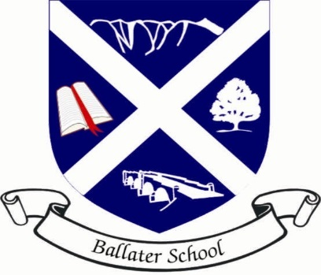

February 2018 News

After a rather disruptive start to Term 3, I am pleased to report that the majority of building works, repairs and upgrades have taken place.

Room One is operating as normal again and our main classroom corridor has been refreshed with a new colour.

Rights Respecting School

I am delighted to report that we have very recently been awarded a Bronze level achievement as a ‘Rights Respecting School’. This means we have been recognised as placing the UN Convention on the Rights of the Child at the heart of our school ethos.

It is our aim to try and achieve a Silver award by the end of this session. The Rights Respecting Group will be working with the Pupil Council to try to develop a global awareness of children’s rights around the world.

School Uniform

A reminder we expect all our pupils to wear school uniform to promote the identity of their school. Staff have reported a few non-uniform hoodies and tops being worn.

Also we have noticed a number of pupils do not seem to have indoor shoes. In order to keep classroom carpets clean and hygienic, please ensure your child has a pair of shoes which fit them and are for indoor wear only.

P7 Leaver Hoodies

Mrs Beaton and I are meeting with the P7 pupils on Tuesday, 20th February from 3.15 – 4.00 pm to discuss whether they want to organise Leavers Hoodies for themselves. We are happy to support the P7s if they do want hoodies, however the main ideas, organisation and effort must come from the P7s themselves as a whole group.
2

20 February 2018

Mrs Strachan’s Class Parent Literacy Session

Parents of pupils in P1/2/3 are invited to attend a literacy curriculum workshop on Thursday, 22nd February at 2.15 pm. The session should last around an hour and the focus is to share new literacy ideas and ways you can support your child at home to build on their literacy.

Please indicate in your child’s diary if you are able to attend this session.

Volunteering Award – P5-7

We recognise that many of our pupils work hard to enhance the life of school in their own time – Pupil Council, Rights Respecting, Green Team, Library, Young Leaders, Lunch Clubs and many others. We are offering these pupils, and those that volunteer their services for community organisations out with the school, the chance to receive some formal recognition for their efforts.

Pupils are invited to sign up for the Young Aberdeenshire Volunteer Award which keeps a record of time given and then awards certificates when targets have been reached.

Internet Safety Session for Parents/Carers

You should have received your invitation to attend the above event on Wednesday, 21st February at 7 pm. We would recommend attendance if possible, particularly if your child is using social media sites as we all learnt a great deal when teaching this topic to pupils.

Mad March Science Day

We are delighted to be taking part in the Mad March Science Festival this year.

The whole school is taking part in activities in school on Wednesday, 28th February led by Sci-Fun and MadLabs.

In addition we will be holding an open session that afternoon from 1.45 – 3.00 pm which everyone is very welcome to come along to. You can join in with the P5/6 workshops or have a look to see what our digital leaders and coders get up to.

3

20 February 2018

In addition to the above day we have some pupils attending the science days at Aboyne Primary on Sunday, 4th March to show case the work they have done on internet safety and coding to the wider Deeside Community. Again all are very welcome to come along to this event.

P7 Young Leaders

Our P7 pupils have now completed their Young Leader training. They will take part in an assessment with Shona Park on Wednesday, 7th March. We look forward to seeing them use their new skills in the playground shortly after this date.

P7 Rotary Quiz

We are again attending the P7 Rotary Quiz this year. The event is taking place on Thursday, 15th March at Logie Coldstone Village Hall.

Mrs Beaton is currently assessing those P7s interested in attending. The top four pupils will make up the team with a fifth pupil coming along as a reserve. Good luck to the Ballater team.

Balgownie Races

We are attending the above event with some of the Mudblaster Runners on Friday, 16th March. We look forward to a fun and successful day out.

Green Team

We are in the process of setting up a school Green Team. The idea is to try to improve our eco credentials in and around the school.

If any parents or other members of the Ballater community would like to be part of this team, please contact the school office.

We aim to hold our first action meeting very soon.

4

20 February 2018

Parental Drop In Session

A reminder that I will be holding my termly parental drop in session on Thursday, 22nd March from 1.30 – 3.00 pm. This is an opportunity for you to meet with me if you have any ideas, opinions or feedback that you would like to share.

