Starting School – Ballater School Houses
Everyone at our school is in a House or team.
We have three teams or houses:
Glenmuick - team colour is blue
Glengairn- team colour is green
Tullich- team colour is red
You will be told which house you are going to be in before you start school.
Why do we have Houses?
We use our house teams for lots of things in school, here are just some of them:
- Sports day- we take part in sports day in the summer and try to earn points for our house.

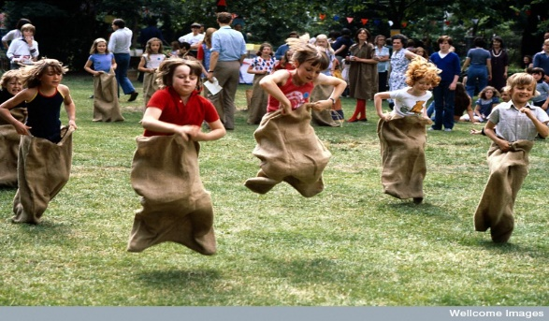

- Lining up after breaks- we normally line up in our house teams when we come back into school after a break outside, we stand behind the coloured cones. The best line gets a point for their house.

- Everyone at Ballater School will have a sticker card. We try to earn stickers by working hard, helping others, representing our school, eating healthy snacks, trying new things and achieving new targets.
When we have earned 10 stickers, we will get a special certificate at assembly and we earn points for our house:

Bronze Award – 10 stickers – earns 5 House points
Silver Award – 20 Stickers- earns 10 House points
Gold Award – 30 stickers – earns 15 House points
Super Gold – 40 Stickers – earns 20 House points

- We have House Captains from P7. Our House Captains organise events for our house including quizzes, fun sessions, games.

- Each of our houses has a flag.

- We count up house points at the end of each term. The house with the highest number puts their flag on the flagpole in the carpark and it flies there until the next team wins.
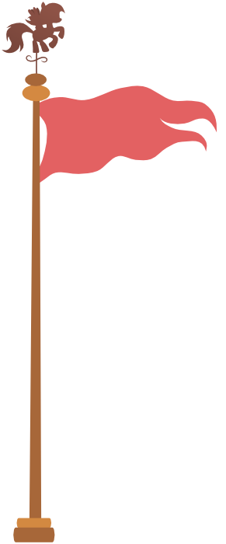

Our flags were designed by boys and girls from each house.
- The winning house each term can choose a prize to celebrate, this can something like a picnic, a movie with popcorn, extra break time, a quiz, ice-cream in the park.

- Sometimes we work together in our houses during assembly time to work out how to solve a problem or think up some new ideas.

