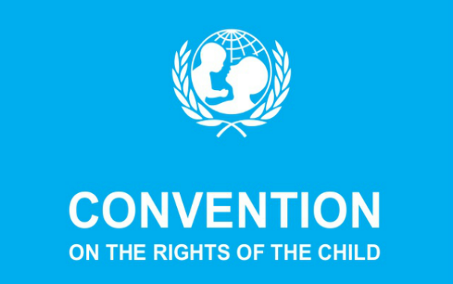
Hello!
We are the new Rights Respecting group of Ballater school. We are getting classes to work more on their Rights and how to respect them. We will also be working to get the community to know our Rights. Anna Wildblood, Archie McEwan, Abbie Jackson, Faye Addy, Freyja Bergman, Rowan Tammi, Oliver Mundy, Caia Thompson, Ava Gildea and Ryah Scripps are the new members of the Rights group.
The group aims to restart the bronze award and we hope to achieve our award very soon.

Our Rights
The Rights Group has put together all the Rights that they think fit with school, here are what we came up with...
Article 1: A child is any person under the age of 18.
Article 2: All children have these rights no matter what they look like, if they are able bodied or not, girl or boy, no matter what all children have these rights.
Article 12: Children have the right to speak freely and voice their opinions.
Article 13: Children have the right to tell people how they are feeling in any form such as drawing, writing or anything like that unless it is harmful to others.
Article 14: Children have the right to have their own opinions and believe in their own religions and adult should support them in this.
Article 15: Children have the right to join or set up groups and organizations unless it harms others.
Article 19: I have the right to be protected from being hurt or badly treated
Article 28: I have a right to education

Our Targets to achieve Bronze level:
- Tell everybody about the Bronze award
- Learn Rights in class
- Set up a Rights Group
- Make Sliver Action plan
- Every class to have a rights charter
- Carry out an all school survey

Below are some pictures of our classroom charters and some other important displays in our school.

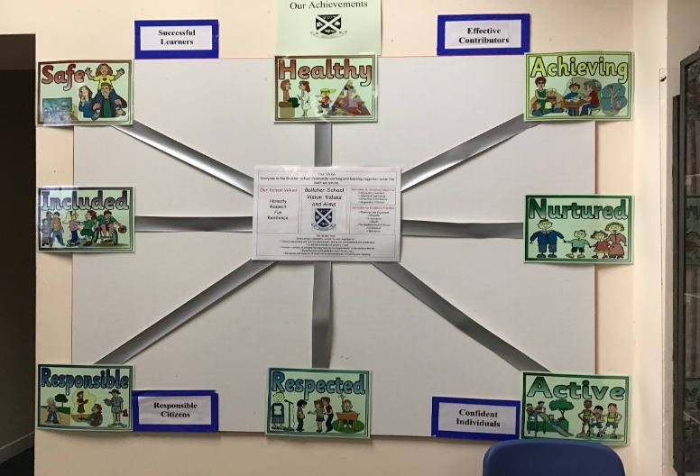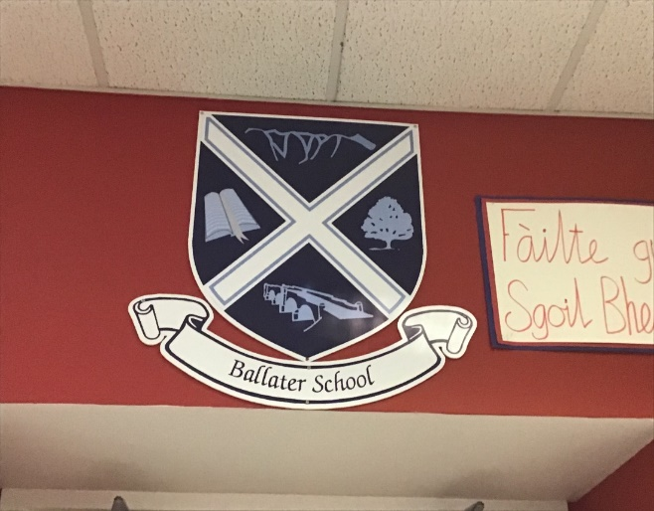
Our Achievement Board, ready for when we can
have assemblies again! School Badge
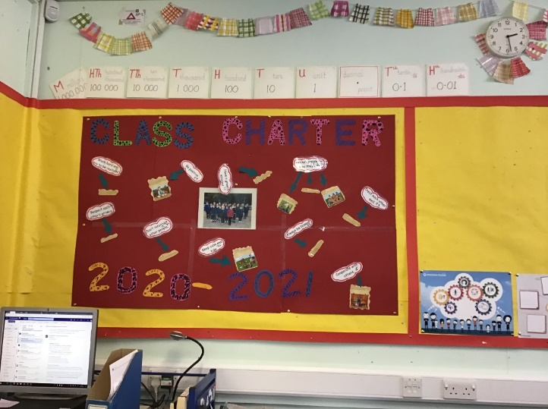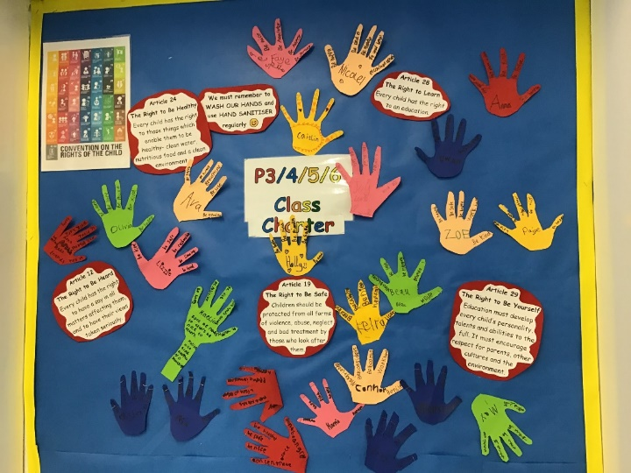
P6/7 Class Charter P3-6 Class Charter
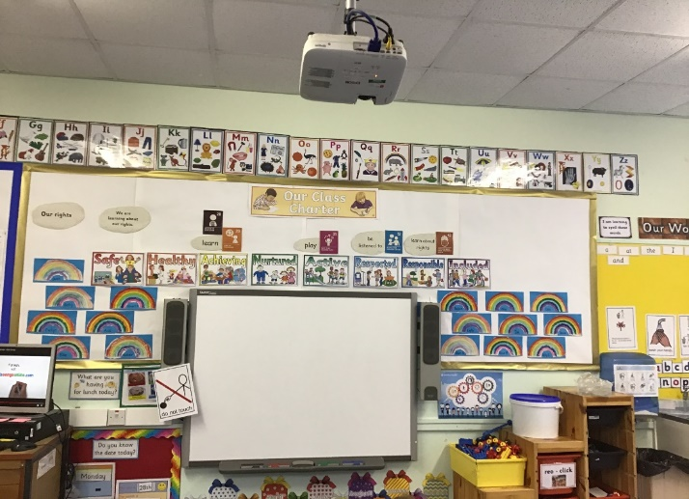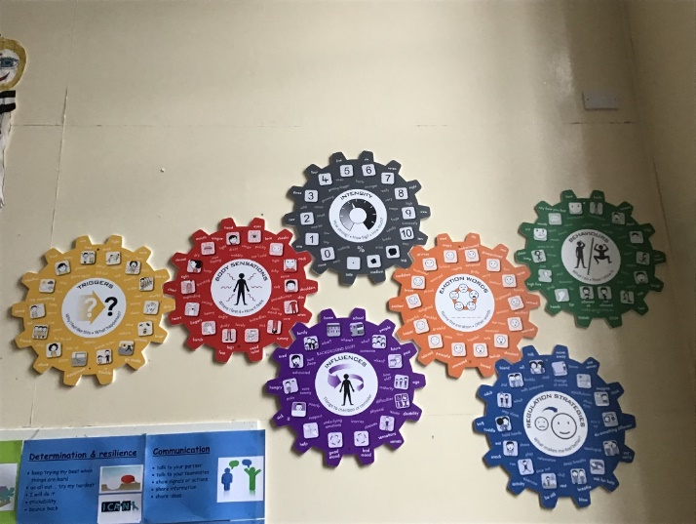
P1-3 Class Charter Emotion Works Cogs
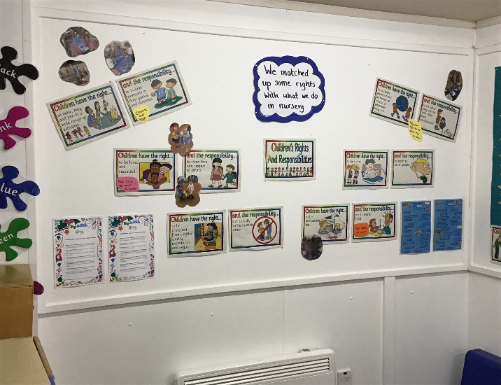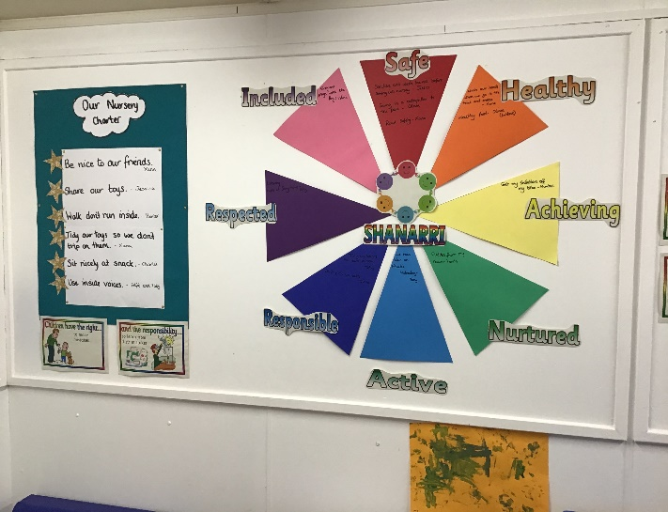
Nursery Rights and Charter

