Ballater School P3-6 Term 1 Newsletter

Dear Parents
I can hardly believe we have reached the end of term! It seems to have crept up on us all of a sudden!
I have had a lovely term getting to know my P3-6 class and I am very much enjoying teaching them. Our class is a busy place, full of activity, sometimes noisy(!), but we are productive and we are all getting on well together. The children have adapted to all the new routines and procedures very well. In fact, I have been impressed at how quickly everyone has adapted.
I asked the class for their input on what they would like me to tell you all about our first term together, so here goes!
We worked hard on creating our class charter during the first few weeks. We looked at the rights of children, which was a recurring theme this term, and we all signed our charter and made promises on tracings of our own hands.
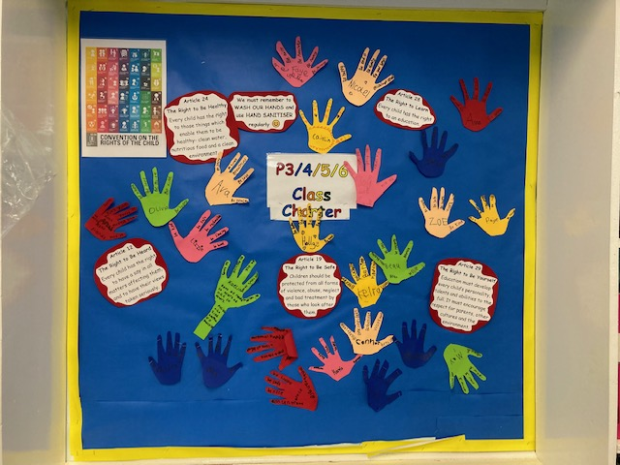
As a school, we have been looking at rights respecting school resources and have had some super discussions about the different rights children and adults have.
We have also spent time getting to know each other’s talents! Each pupil made a paper chain of 5 things they are good at. We then linked the paper chains together into a huge chain, which is hung up in class. This is to remind us that we all have our own talents and that when we work together, we combine all those talents to become a great team.
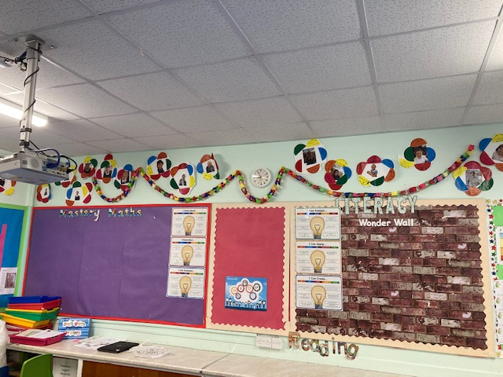
The past 2 weeks, we have started to learn how to order our lunch in French. The pupils have enthusiastically taken this on board, and are already competently ordering their lunches, based on the colour of the lunch choices. Next term, we will start to learn the French words for different items on the menu and incorporate this into our daily routine.
As you know, we have moved on to multiplication and division in numeracy. We are learning our times tables through a variety of games and songs which we listen to. Learning our times tables is such an important tool which opens up lots of different areas of numeracy. The better we know our tables, the easier numeracy will become!
We have also been doing lots of work on emotions throughout the term and we will continue with this next term. We have looked at emotion words, behaviours and body sensations that can happen when we feel certain emotions. The pupils came up with lots of emotion words and created a display on their board in school:
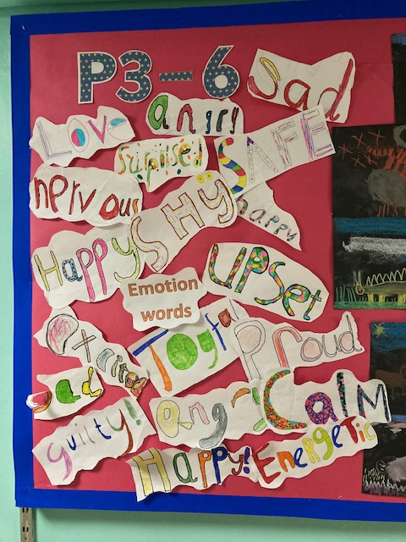

Throughout the term we have been reading “Charlotte’s Web” as a class novel. Everyone seems to have enjoyed reading this story and we have taken part in some interesting drama and role play activities, as part of the learning associated with the novel. Today we have had huge excitement as we watched the movie in class! It was a lovely way to end the term.
We say Goodbye to Lizzie Hay who is leaving us today. We will miss her very much and wish her lots of luck at her new school.
Please do not hesitate to contact me if you have any questions or worries.

Kindest Regards,
Mrs. Davidson

