Ballater School P3-6 Term 2 Newsletter
Dear Parents
What a quick term this has been!
We have been very busy, getting through lots of work, and having fun at the same time!
We have had a super addition to our class this term, in the form of Mrs Greig, our new PSA. She is fantastic and is working mostly with P3-6 currently, and we are very lucky and grateful to have her.
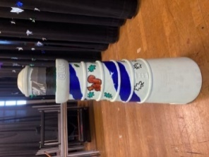
A focus this term has been our lighthouse project for CLAN. We have had fun learning about lighthouses and designing a healthy lunch for a lighthouse keeper! We then went on to paint the lighthouse in stages. The finished product looks amazing, but we are not permitted to display any pictures of the finished lighthouse until the trail opens in the Spring 2021. We will of course share the photos of the children with the finished product when we are allowed to do this. In the meantime, here is a picture taken during the painting process, which some of you may not have seen already.
P3 and P4 have been spending an afternoon a week with Mrs. Garrett where they are concentrating on writing. This is a great opportunity for them, and they are really enjoying it. P5 and P6 are concentrating on writing a character description. We are learning all about the different techniques we can use to improve our writing and can’t wait to see the new and improved descriptions next term.
We have finished our topic on division in Numeracy. Everyone worked hard and did very well. We used blocks in class to help us with division and natural materials outside too. This helped the pupils to get to grips with what division actually means. Here are a couple of pictures of the pupils using the materials.
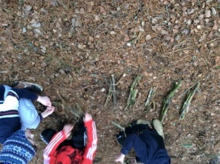
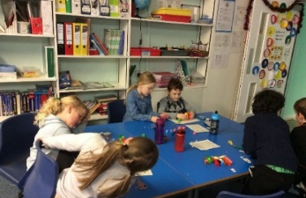
We are now moving on to Time, which we will continue next term.

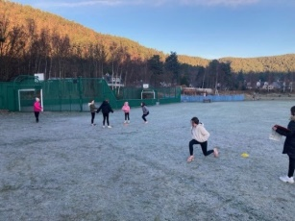
P3-6 have done very well in PE this term. As you know, we have still had to do PE outside. It has been very cold on some days and all pupils have been great at “getting on with it”. We have been taking part in a fitness challenge, trying to develop and sustain our levels of fitness, as well as giving feedback to each other. Here is a picture of the pupils working hard, on a very cold morning!
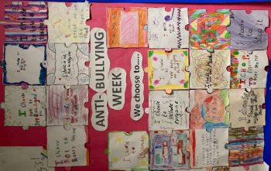
In November, we had anti-bullying week, where we had lots of discussions and activities around anti-bullying. We ended the week by decorating a jigsaw piece each, which said “I choose”. The pupils wrote their own captions, such as “I choose to include everyone”. We have put all the pieces together and displayed them on our board.

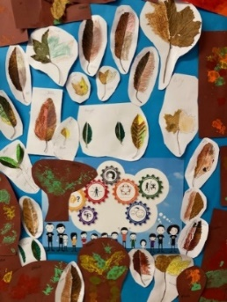
We have been doing very well at ordering our lunch in French and adding in new foods every few days. This has become a routine in class. We are now asking to go to the toilet in French and are beginning to learn how to describe eye and hair colour in French.

We completed some autumnal art using leaves in November. Firstly, we split leaves in half, and learned about symmetry and then we used paint and made some leaf printed trees to display in class.
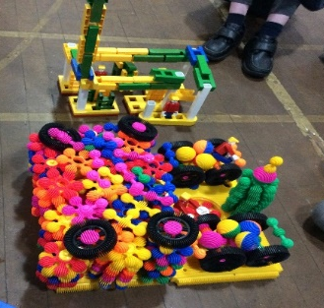
Last week, we completed a construction challenge centred around the theme of a “Christmas scene”. Everyone worked very hard and the creations were so imaginative! Here are the pictures of our completed Christmas scenes.

Last week, we also had a focus on dyslexia. We learned lots about it and took part in activities to help us all understand dyslexia more.
During this term we have been reading “Midnight Gang” as a class novel. Everyone seems to have enjoyed reading this story and we will continue reading this next term. I have been impressed at how well everyone has listened. It is a nice quiet way to end the day!
Wishing you all a happy and peaceful Christmas and New Year.
Kindest Regards,
Mrs. Davidson

