Ballater School “Virtual” Christmas Fair 2020

We are delighted to be able to share with you our festive goods for sale. P1- P7 pupils have been very busy designing and making the goods you see below which we hope you might like to purchase.
We have tried very hard to make use of some of the natural materials from our school grounds to make our items.
Funds raised will be split between our school fund and a charity the pupils are going to choose.
To order any items, please email on ballater.sch@aberdeenshire.gov.uk stating which items you would like and how many of them.
We will deal with orders on a first come first served basis.
Items can be paid for either cheque or the exact amount in cash- please place cheques or cash in an envelope with your name and the full amount written on the front. Please do not come into the school building to deliver payments, either send your envelope in with your child or knock on the office window and Jenny will come out to collect your envelope from you.
Cheques should be made payable to Ballater School Fund
All items have been quarantined in the school and orders will be made up by one person wearing the appropriate PPE ready for sending home.
We will email you to confirm the day your order is ready.

Please indicate below how you would like your order delivered to you:
I would like to collect my order from outside the school office at 3.15pm on the day my order is confirmed.
Or
I would like my order put into my child’s school bag on the day my order is confirmed.

 | Name of object | Price of object
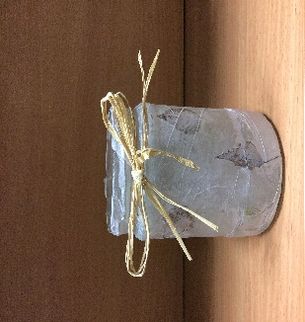 | Nature Tea Light Jars | £3.00 each
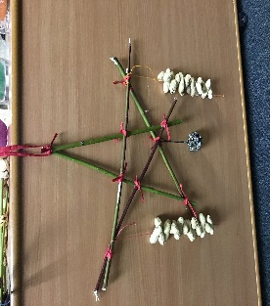 | Bird Feeder Stars | £3.00 each
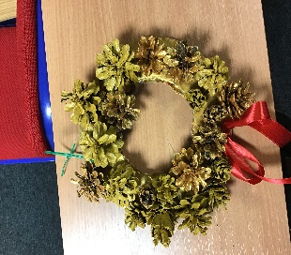 | Cone Wreath | £2.00 each
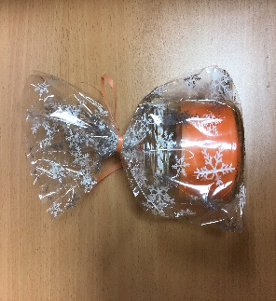 | Handmade Scented Candles | £4.00 each
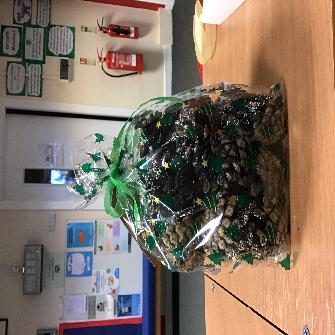 | Scented Ballater School  Pinecones | £3.00 each
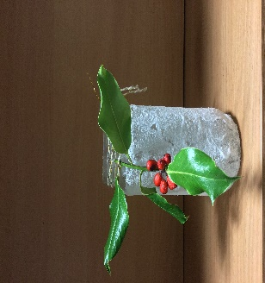 | Salt Jar Tea Light candles | £2.50 each
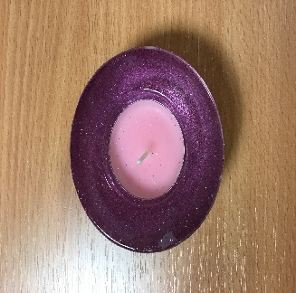 | Sparkle Mini Tea Light Glasses | £1.50 each
Photographs by P6/7 pupils.

