TERM 2 NEWSLETTER P6/7
I can hardly believe we have reached the week before the Christmas holidays. Here is a flavour of what P6/7 have been up to this term.
Awareness Weeks
We have had two weeks this term highlighting two important topics. In November we had an anti -bullying focus week which coincided with the launch of the school’s new anti-bullying policy. Our class took the document and changed it into a child friendly version for the younger pupils in the school.
In December we had a dyslexia awareness week. It is important that all pupils understand what dyslexia is and how it affects some of us- it’s positives and negatives.
Google Classroom
As you will be aware Seesaw has been withdrawn by Aberdeenshire Council. In order that we have some sort of digital platform to communicate with pupils we have introduced Google Classroom. All pupils have an account and the first batch of homework was posted on it last week. As of January, homework will be posted here weekly every Thursday and it will be due on a Wednesday unless otherwise advised.
Literacy
In term two we have spent a bit of time practising our joined handwriting. In story writing we have been learning how to hook the reader and build suspense. We have had two reading books this term- Kensuke’s Kingdom and Why the Whales Came, both by Michael Morpurgo. We have read two class novels, by the same author, There’s an Elephant in the Garden and Born to Run.
Numeracy
This term as well as basic mental maths we have studied co-ordinates, properties of triangles, how to find the area of a right angled triangle and scale. We just started work on percentages.
On-line Shopping
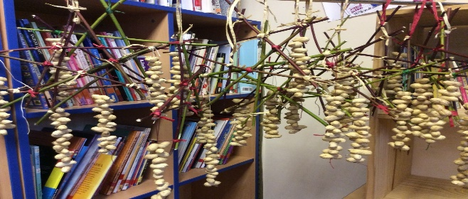
We made bird feeders by lashing together dog wood and hanging peanuts on them, as well as a pinecone dipped in fat. Groups of children also helped make scented candles with Mrs Duckworth.

Christmas
Christmas in school this year is very different. We have planned our own class party. We have voted on what Christmas film we want to watch. We have made cards for the residents of a local sheltered housing complex. We have also made digital cards to send each other this year. This also gave us practise in emailing and word processing.
P6 Bikeability
This term it was the turn of the P6s to improve their safety on the road skills. They worked hard and the pass rate was very high. Well done.
Christmas Technology
This week we were given a brief and had to plan and build a Christmas scene using construction materials. Unfortunately, it was a day when there were six absentees, but here are some completed models.
