Ballater School
Weekly Update Friday 26th March 2021

We reach the end of another busy and hopefully a little more settled week.
Outdoor Classroom
We are delighted to see our outdoor classroom taking shape in the form of the gazebo in the wild woods. Continued thanks to our Parent Council for organising the funding and installation of this fantastic resource. Thank you also to Stephen Clark and his helpers for their hard work installing.
We are very much looking forward to being able to use this space along with some lovely new resources for outdoor learning that have been purchased with a generous donation from the Busy Bees group.
Morning Snack
The snacks provided by the Parent Council have started this week.
The snacks planned for next week are:
Monday: Kellogg’s Nutrigrain cereal bar
Friday: tangerine
As before any spare fruit will be available outside the school office at the end of the school day for people to help them selves to- please use the sanitizer provided before taking fruit.

Parental Feedback
We issued a short Forms survey yesterday to provide us with feedback on how you feel the return to school has been for your family.
Thank you to the families who have already taken the time to complete the survey for us. We would be delighted to receive feedback from as many families as possible.

Next week
From 29 - 31 March many of the school staff including the head teacher have external commitments. This means that Mrs Garratt will be teaching in P3-6 and Ms Yule will be teaching in P6-7 and the senior leader in school on these days will be Deborah Masson (Quality Improvement Officer). The school office will be fully staffed so should you need to contact the school for any reason the usual email and phone numbers can be used.

Well Done
It was lovely this week to see some of our pupils work in the Press and Journal gallery of Lockdown heroes. It was great to see Ballater being represented to such a high standard in this publication.
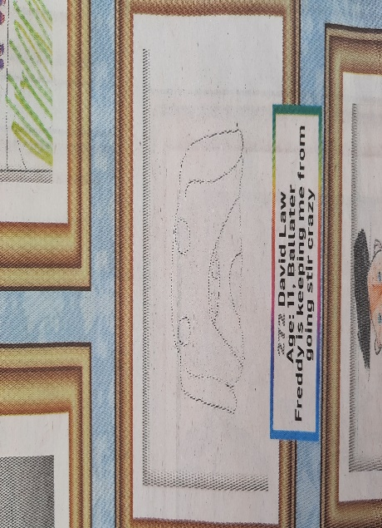
David P7 Caitlin P5
Cooper P3 Ryah P7

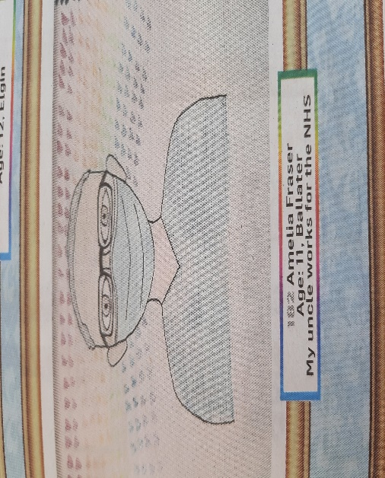
Amelia P7
Finally
A reminder that next week will be a slightly shorter school week as term three finishes at 3.15pm on Thursday 1st April for the Easter holidays.
Wishing everyone a restful and enjoyable weekend.
The Ballater School Team

