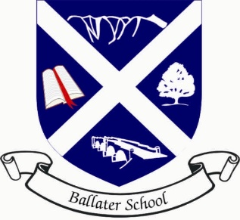
Ballater School
Weekly Update
Friday 14th May 2021
Next week will see us at the halfway point of this term, it seems to be going so quickly!

Breakfast Packs
We are delighted to be giving out the breakfast packs on Monday for those families that opted into the project organised by the Parent Council. The packs look great and we can see that a huge amount of time and effort has gone into making these up. Thank you to the ladies of the cooking team for all their efforts.
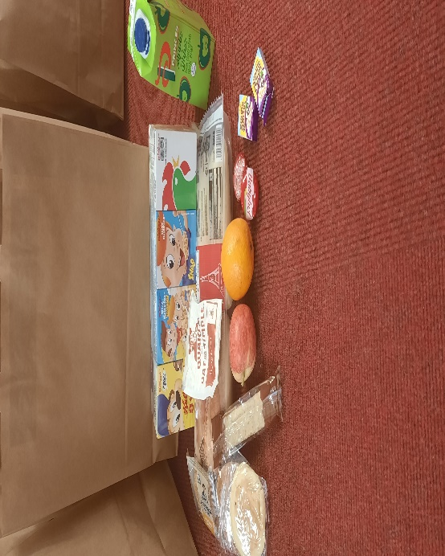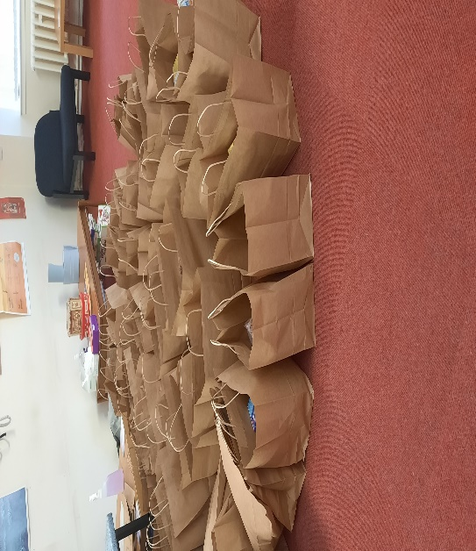
The Breakfast packs ready to go out on Monday.

Monday and Friday Snacks
We are still using some of the snacks in school next week. These will be cereal bars and bread sticks.

Parent Portal
A reminder, if you haven’t already done so, to sign up to the Aberdeenshire Parent Portal. Being signed up will simplify paperwork for home and school and will cut out the need for most paper copies. If you are unsure how to go about this, please contact Mrs Florence in the school office.

Nursery to P1 transition
It has been great to see our new P1 pupils in school now a couple of times. We hope they are enjoying their visits and finding them useful. We will continue to send out the weekly information sheets to parents. As always if you have any queries, please get in touch via the school office.

Always we wish you a restful and enjoyable weekend.
The Ballater School Team

