Ballater School
Weekly Update
Friday 4th June 2021

What a difference the lovely weather makes, although the heat and probably general tiredness as we get toward the end of the year has resulted in a few social problems between pupils this week.
Ballater in Bloom
All the classes have had the opportunity to be part of the wildflower seed sowing this week. We are grateful to the Ballater in Bloom team for inviting us to take part and I know from feedback from most pupils and staff that it has been an enjoyable activity to be part of. We hope the weather conditions will be favourable to the seeds growing and providing a great display for people to enjoy and also some food for our wildlife.

Gardening Club
Although we have been unable to get the pupil involvement part of gardening club going yet, it has been great to see lots of volunteers assisting in getting our school grounds ready for later in the year when our pupils can join in. Thank you to Nicole and Laura for co-ordinating the preparations and to all the volunteers from the community who have been helping out.
Memorial Garden
We have been pondering for a long time on how best to create a memorial garden area at the front of the school to remember Kathleen Cowe. Kathleen was our nursery teacher who died very suddenly a couple of years back but is still fondly remembered by many staff and pupils in the school.
We have placed an order to have a barrel train made (see picture below) which will be filled with some bright flowers and plants for us all to enjoy. We have also ordered a few barrel planters which along with the beautiful plaque created for us by Gillian Ingram, should create a fitting memorial to Kathleen.

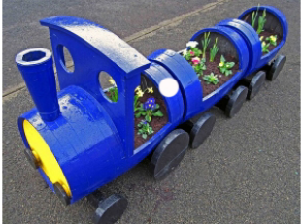

School Uniform
We have had a few requests for the name of the company who supply our school uniforms.
Online orders can be placed at: www.schoolwearmadeeasy.com

Class Outings
We have made provisional diary dates for the three main classes to go on local outings in the next few weeks. The dates are conditional on staffing, weather and a couple of other logistics.
Wednesday 16th June – P6/7 Walk to Tullich
Monday 21st June – P1-3 walk to Sluievannachie
Tuesday 22nd June – P3-6 walk to Tullich
Each class will be issued with consent letters next week which will contain all information required for these outings.
I understand the nursery have plans for a local outing which will be shared with parents shortly.

P1 Transition
We have been pleased to have our new P1s coming through to their new classroom for several weeks now as part of their transition.
Next week the new P1s will be having their lunch (nursery menu) in the dinner hall at 12 noon, ahead of the rest of the school coming through.
From Monday 14th June the new P1 s will have their lunch about 12.10 to gain some experience of being in the hall with some of the other pupils.

As always, we wish you an enjoyable and restful weekend
The Ballater School Team

