Ballater School Weekly Update
Friday 24th September 2021
We have had a very exciting week! Our new Parent Council has been elected at the AGM on Monday and are raring to go at their next meeting on Monday 4th October. Some pupils attended the tennis session courtesy of Ballater Tennis Club with Judy Murray. Our beautiful new barrel train was delivered on Thursday along with some new barrel planters and finally, not so positive but still causing a stir, we have many pupils absent with chicken pox!
Next Week – IDL Week (Inter Disciplinary Learning)
We will be learning in slightly different ways next week. We will be posing a question to the children in all classes which they will then have to prepare their answers ready for Friday when they will be sharing their work with the rest of the class, their teacher and Mrs Duckworth. The question will have a link to the learning the classes have been focusing on based around the science topic they have worked on for a few weeks. Normal timetables will not operate next week apart from PE which will continue in the normal time slots. The pupils will be responsible for how and what they share to showcase their learning.
This is the first time we have given pupils this opportunity to share their learning in this way, we are very excited to see how everyone gets on. We will share photos of some of the presentations in the weekly update and it is our aim in the future to invite parents into school to share these learning sessions with our learners.
Lunch Hall – Ballater School Restaurant
We have identified that the noise levels in the dinner hall have recently become too high. We asked pupils for their ideas on how we can reduce the noise to allow everyone to enjoy their meal. Pupils suggested that we should treat the dinner hall more like a restaurant or a café and try to behave as if we were visiting one of these. We have agreed to: speak in a quiet voice to the people directly beside us instead of turning around and shouting across to other tables, sit properly on our seats until it is our turn to tidy up and use our cutlery properly.
We hope that these ideas will work and allow everyone to enjoy their lunch in a more restful environment. It would be great if these expectations for behaviour could be reinforced when you are eating together at home.
School Fruit
We are pleased to see that we have a great crop of apples and brambles in our school grounds this year. We are going to pick these and freeze them to allow us to use them for cooking with the classes when we are permitted to cook again.
Please do not pick our produce, as we need them for our school.
Barrel Train and Memorial Space
As mentioned at the beginning, we are very excited to have taken delivery of the barrel train.
It is to be used for growing plants which we hope will encourage the bees. There are also four other barrel planters which will be given to each class to decorate and then look after with plants of their choice. A beautiful memorial plaque will also be placed in the area around the train and planter to complete the memorial space for Kathleen Cowe, a much loved member of staff who died a couple of years ago.
Please respect this special area and do not use it as a short cut or for climbing on etc.

Photographs
A reminder that information was sent out this week on how to view and purchase the photos of pupils taken recently by Aboyne Photographics.
Tennis
We were delighted to have some our pupils take part in the tennis event organised by Ballater Tennis Club on Wednesday. It was fantastic to see the youngsters and their parents having such a good time and learning so much courtesy of Judy Murray. Every person that attended the event was a truly positive ambassador for our school and community. I know our staff have taken away some great ideas to continue to develop these skills, but as Judy herself said it is up to our parents to be providing these opportunities to practise and have fun outdoors, she didn’t end up with two champion tennis players by doing nothing with her boys.
Gardening
Unfortunately, we have had to postpone our planned gardening experiences this week due to illness. We look forward to getting our gardening gloves on when everyone is fit and well again.
World Record Cyclist
We are looking forward to welcoming Josh Quigley to Ballater School next week. You will be aware that Josh recently gained a World Record in distance cycled in a week. His route included Ballater and he is keen to speak to our learners as Ballater community gave him great support. We understand he should be visiting us sometime on Thursday afternoon, but this is still to be confirmed.
As with Judy Murray, another great role model for one of our school values- Ambition.
Parent /Teacher Conversations
A reminder, if you would like to speak to your child’s teacher this term, to contact the school office as soon as possible to arrange a time.
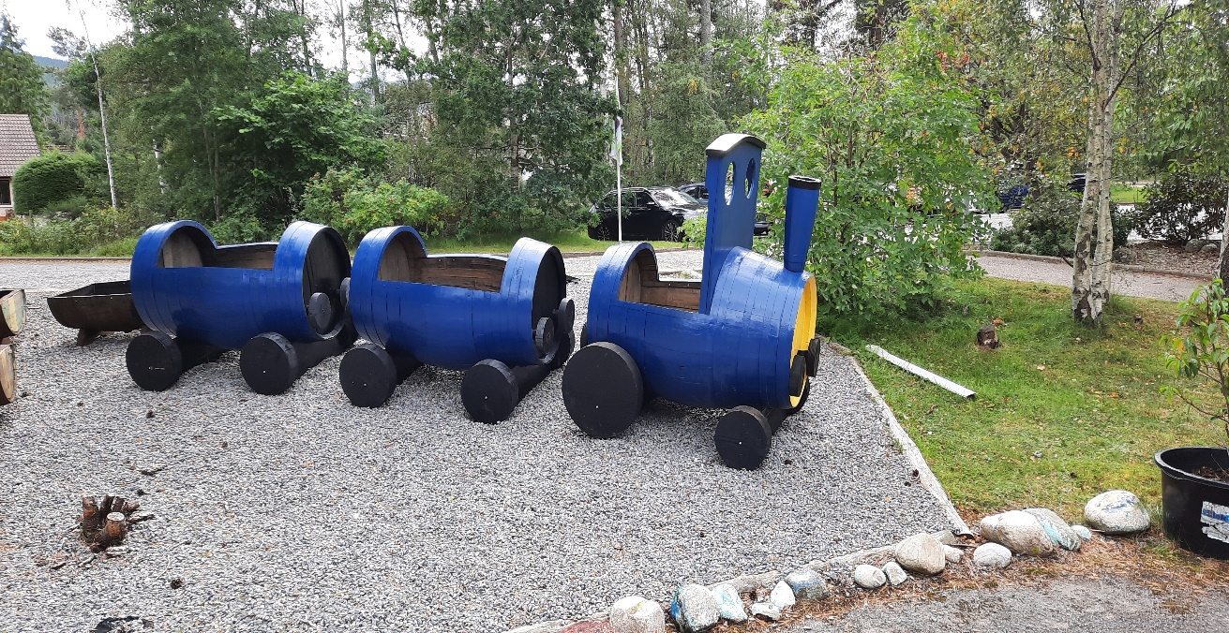
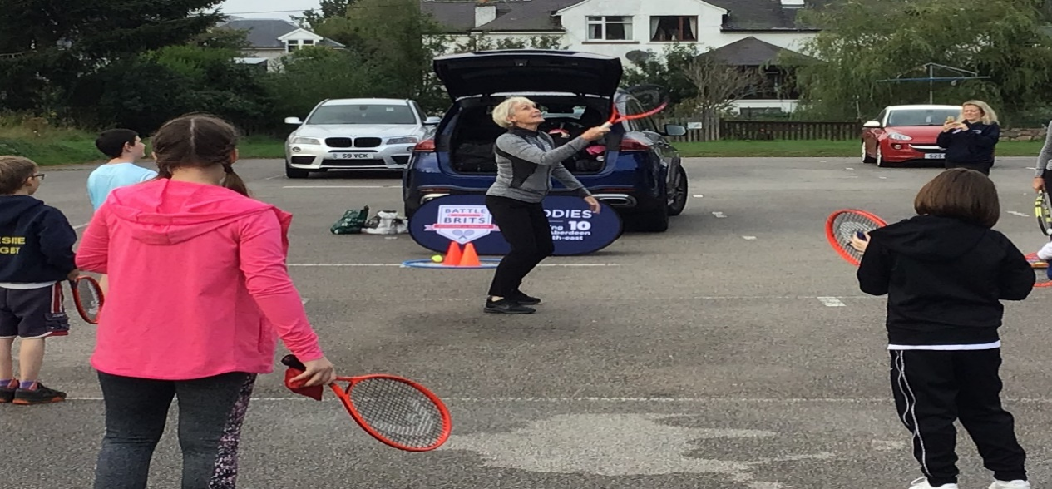
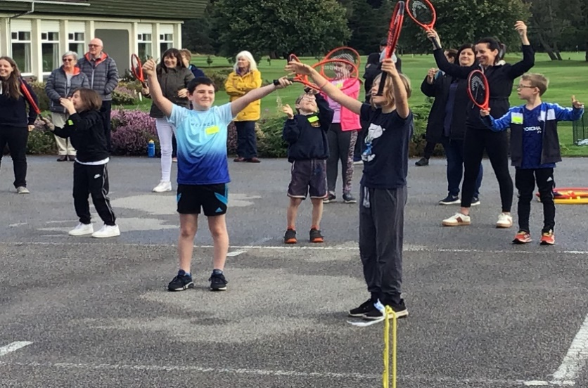
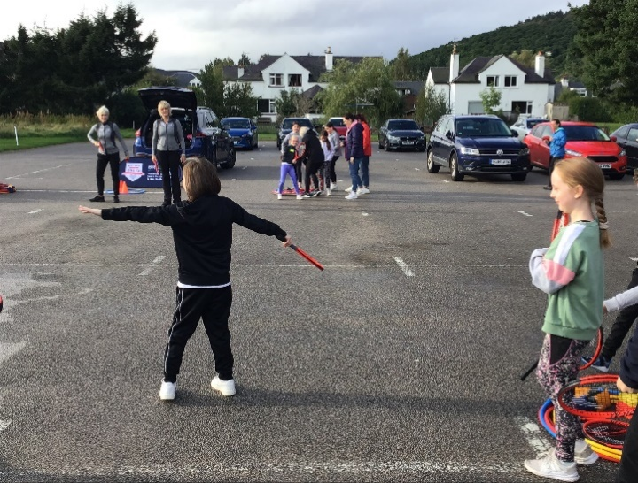

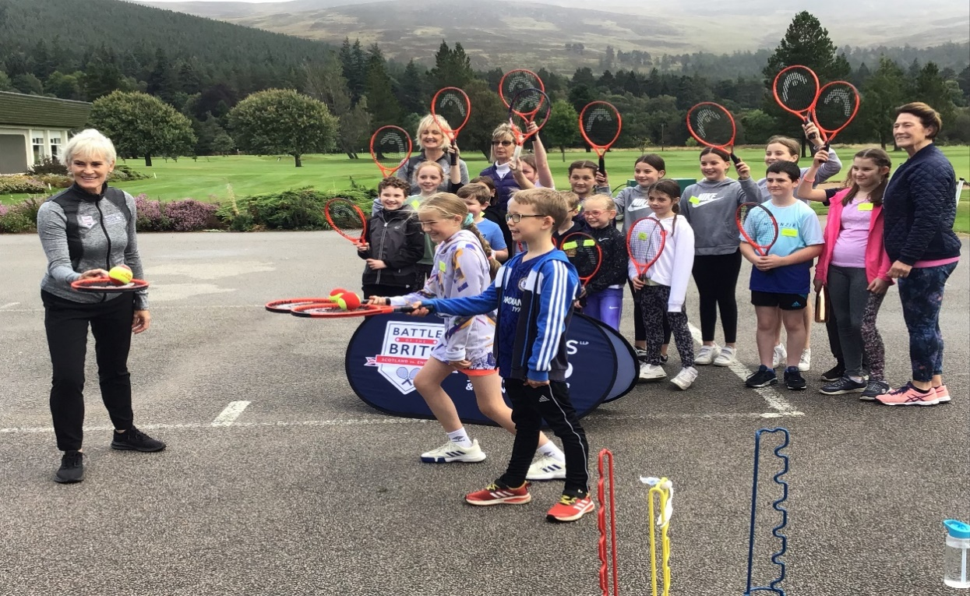

Have a safe and restful weekend!
The Ballater School and Nursery Team

