Ballater School
Weekly Update
Friday 27th August 2021

We have had a really busy week with everyone settling back into routines and friendships. Our P1 have reached the end of their first full week of school, we suspect they might be quite tired, staff certainly are! The new children in the nursery are finishing their transition visits over the next week and we look forward to welcoming them full time very soon.
Class Communications
We hope you have found the P1-7 class newsletters and timetables informative and helpful. We have worked very hard on curriculum structure across the week and school year and will continue to focus on consistency across the school this session. We will provide you with further information very shortly on some of the developments we have undertaken such as curriculum, learning and teaching and sharing learning.
The nursery team are aiming to post daily updates on their Facebook page where possible.
PE
There has been great excitement about being able to change for PE again. Please could you make sure that all clothing, school uniform and PE kit, including gym shoes is named. After only one week we already have a mystery pile of clothing with no names on the items!
All hair longer than shoulder length must be tied up for PE (it currently should be tied up at all times in school due to Covid mitigations).
If your child has pierced ears, earring should either be removed on PE days or your child should have a roll of medical tape in their PE kit to cover their earrings for PE.
Community Links
We have been approached by Ballater Climate Action Now group to link up on some shared projects.
We will be learning about recycling, where does our waste go, could we recycle more, assisting with a community litter pick and later in the Autumn we will be helping collect acorns from Craigendarroch as part of a programme to regenerate the oak woodlands on the hill.
These projects will link very well with out forthcoming cross curricular focus which is based around looking after our environment and COP26 which is taking place in Glasgow.
Further information on Ballater CAN can be found on their Facebook Group : Ballater CAN 2021.

Gardening Team
We have some exciting plans to finally be able to start pupils working outdoors with the gardening team. Small groups of pupils will take turns to work in the school grounds, starting in the next few weeks.
Finally
We received this photograph this week from a lady in England whose mother-in law is in the picture. We have worked out that the picture is of pupils at Ballater School – soon to be lovely new homes, in about 1910. Her mother-in law was called Jeannie Troup and is second from the left in the second from back row of the picture. I wonder if anyone else may have relatives in this picture? Can anyone tell us who any of the pupils or the teacher is?
It is amazing to see what pupils (and staff) were wearing just over a hundred years ago, quite different from our current sweatshirts!
We will pass a copy of this picture onto the Ballater Local History Group as they maybe able to identify some of the faces.
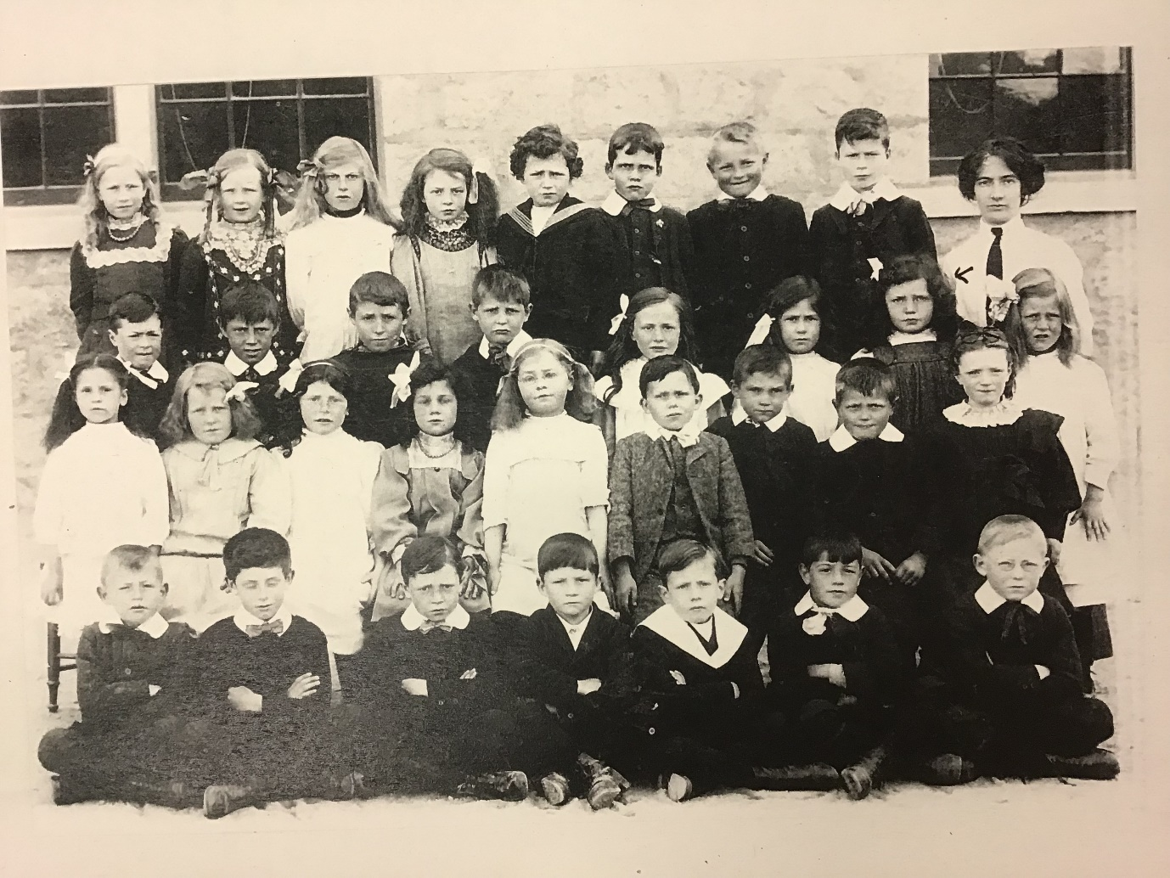

Wishing you all a restful and enjoyable weekend.
Stay safe!

Ballater School and Nursery Team.

