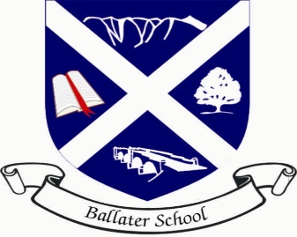
Ballater School Weekly Update
Friday 3rd September 2021
This has been an unusual week in school. The classes are all settling into their new routines, you will have all received your class newsletters from your child’s teacher and also a copy of their timetable which we hope you will find useful. We have been working on a revised structure for our class timetables which should provide you with greater detail on what is happening in the classes.
As mentioned last week, we will be issuing information to parents on what our curriculum looks like, what learning and teaching looks like in a classroom and also how we intend to share learning with you.
The first information sheet will be issued next week looking at our curriculum.
Photographs
We are delighted to again have Aboyne Photographics coming to take pupil photographs this term.
We received very positive feedback from our survey last term about using Aboyne Photographics which is why we have decided to ask them to come back again this year.
Photographs are due to be taken on September 16th, weather permitting as they are again to be taken outdoors. Further information on the photographs will be issued next week.
Covid
Unfortunately, we have seen a rise of positive cases of Corona Virus within the Ballater community.
To date, we have had one positive case in school since the summer break which was a member of staff and as they had followed the mitigations in place in school, nobody was identified as a close contact and no further action was required. Currently we do have several pupils absent as they have been identified as close contacts and they are awaiting results of their PCR tests.
If any pupil from our school tests positive, we will issue an NHS Warn and Inform letter to parents and guardians of pupils in the same class.
The guidelines have changed considerably since before the summer and we are doing our best to keep up to date with changes as cases emerge. If you or any member of your family has tested positive or been identified as a close contact and you are unsure what to do next, please contact us and we will do our best to advise you.
Schools have the benefit of a weekly meeting with NHS Grampian clinicians where we can ask questions and receive the most up to date information.
Annual Data Update
A reminder if you have not already done so to make sure you have gone onto Parentsportal and checked that all the data that is held for your child is correct.
The link to access Parentsportal is below:
https://www.aberdeenshire.gov.uk/schools/school-info/parents-portal/
School meal payments can also be done through Parentsportal.

School Meals
A reminder that all pupils in P1-P4 (and nursery) are entitled to receive a free school meal each day.
From January, P5 pupils will also be entitled to a free daily meal too.
It is helpful if you can discuss with younger children what the meal choices are for school meals.
The current school menu can be accessed on the following link:
https://www.aberdeenshire.gov.uk/media/26166/school-menu.pdf

Flu Vaccine
A reminder if you have not already done so to return the consent letters issued by the NHS for the forthcoming Flu vaccinations.
These vaccinations will take place in school before Christmas, we will let you know when we have confirmed dates.

Wishing you all a restful and safe weekend.

The Ballater School and Nursery Team.

