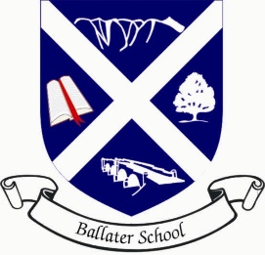
Ballater School P3-5 Term 1 Newsletter

Dear Parents
My name is Mrs. Davidson and I will be the P3-5 teacher for the academic term 2021/2022. Some of you already know me from last year, and our ”learning at home” interactions! I am so happy to be teaching your children again and I am very much looking forward to working with the new children in class and meeting you all during the year.
A timetable has been sent out so hopefully you will see the mix of curricular areas which we will be covering on a weekly basis this term.
We are lucky to have Kodaly with Mrs. Malone this term and Mrs. Garrett covering one afternoon a week. Mrs. Garrett will be concentrating on HWB alongside talking and listening, as well as a block of art, which I am sure all the pupils will enjoy.
PE will be on Mondays and Wednesdays, subject to the odd change!
Our focus in literacy this term, will be to extend our writing skills. The children are going to have a chance to vote on the type of writing they would like to focus on. Our focus in numeracy will be numbers, number processes and place value, followed by addition, subtraction, multiplication and division.
I am already impressed with how well the class work together and the kindness they show to each other. I am really looking forward to our little team working hard this term and having lots of fun while we do that.

Please do not hesitate to contact me if you have any questions or worries.

Kindest Regards,
Mrs. Davidson

