Ballater School
Weekly Update
Friday 8th October 2021

Despite the unusually warm weather, there has definitely been a more autumnal feel this week with darker mornings and the trees starting to turn.
We are pleased that most all of pupils in the first group who had chicken pox have recovered and are now back with us in school, unfortunately we are still seeing a few new cases emerging.
Cross Curricular Learning
Our classes have moved onto their geographical/global themed learning this week which has coincided nicely with some input from members of Ballater Climate Action Now group. All the classes have had the chance to learn about the importance of recycling in our homes and also to take part in a litter pick in an area near the school. We have also restarted our school recycling routines again after a break due to Covid. P1/2 are responsible for our cardboard, P3-5 for compostable materials and P6/7 for paper and plastics. We are busy training pupils up on our recycling routines with the aim of less general waste being put into our trade waste bins.
We have also been asked to share information about a community litter pick which is taking place tomorrow- see below. It would be great to see some of our school community getting involved.
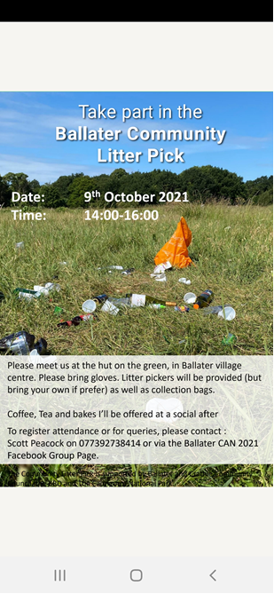

Pupil Safety- P1/2
Thank you very much to everyone who have been letting us know in advance of any changes to the end of day picking up arrangements.
In addition to this we have spoken to P1/2 about the importance of waiting in their line at the end of the day until the accompanying member of staff has seen the adult that is there to collect them. We were a little worried that sometimes some children had run off to meet a parent before we had the chance to make sure they were going with the correct person.
We hope this will help keep all our children safe.
Josh Quigley
Please see the message below from Josh.
I'd like to say a massive thank you to all the pupils at the school for taking the time to listen and also for asking some brilliant questions. It has been a fun two weeks and an amazing follow on from breaking the record. I hope that the kids, teachers and parents feel inspired to keep moving forward and maybe even attempt a record of their own.
The achievement, that belongs to not only me, but my team and the supporters, has been recognised by a major cycling publication and we would really appreciate any votes, link provided below
https://www.surveymonkey.co.uk/r/cyclingweekly-awards-vote21
All the best
Josh Quigley
Nursery
The Makaton signs the children have been learning this week are family, mummy and daddy (mum and Dad)
Click on the link below to see the signs in action.
https://sway.office.com/cim9VoTtlPtnPPSz?ref=Link
Also, a reminder from the nursery team to make sure you child has appropriate wet weather clothing with them as the children are likely to be outside daily
Curriculum Rationale Refresh
We are in the process of refreshing our curriculum rationale- the purpose to what we teach in school. We are currently asking all pupils, staff and parents/carers for their thoughts and opinions to get us started on this refresh process.
We would be very grateful if you could take the time to complete the attached survey to give us a parental perspective.
https://forms.office.com/Pages/ResponsePage.aspx?id=BpPZ_i1NCUSVndDttzBKC_oZihCN7iZJlgUhV5yUcrBUNTdVVElaN0Q3QTA0SVpIWlJUR1hBU1Q0Ty4u
Staffing
Mrs Beaton is to be commencing a pattern of phased retirement working from November this year. She will be working three days a week. We held interviews this week and have a preferred candidate for the remaining two days a week in P6/7.
We will share further information when all the necessary paperwork and checks have been completed.
Wishing everyone a safe and healthy weekend
The Ballater School and Nursery Team.

