Ballater School
Weekly Update
Friday 12th November 2021
We have had quite a challenging week due to staff absences. We have been pleased to have welcomed Mrs Morrison and Mrs Taylor to Ballater to help cover for absent staff. We look forward to seeing everyone back when they are feeling better.
‘Flu Vaccines
On Monday we had the school nurse team in school to deliver the ‘flu vaccines to pupils in P1-7. Pupils received the nasal spray. Thankfully it all went smoothly. Any pupils who were absent on the day should have received a letter with alternative arrangements on it.
Children In Need
Pupils have decided at the last minute that they would like to do some fundraising for Children in Need.
The event will take place on Wednesday and those pupils who would like to take part are encouraged to bring in a money donation. Pupils can wear their pyjamas to school and funky hair and crazy faces will be welcomed too! We look forward to seeing everyone in their unusual outfits on Wednesday.
In- Service days
On Thursday and Friday next week the school will be closed to all pupils due to Aberdeenshire In-Service days.
Remembrance
Yesterday at 11am the whole school participated in a small ceremony to mark Remembrance Day. We gathered for two minutes silence, we listened to the Last Post and we heard Mrs Duckworth play Flowers of the Forest on the bagpipes. Some of our P7 pupils will be representing the school at the community wreath laying ceremony on Sunday morning.
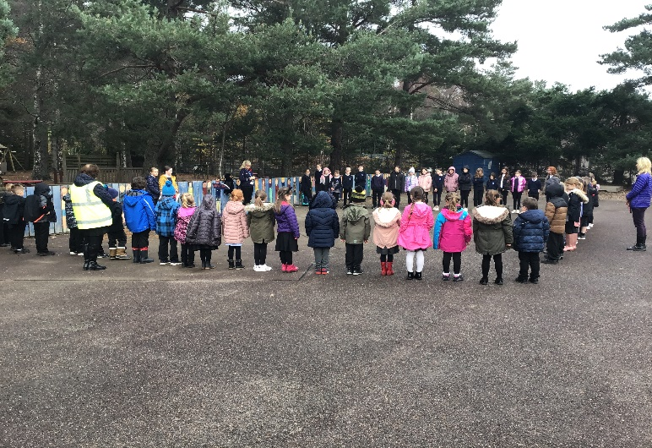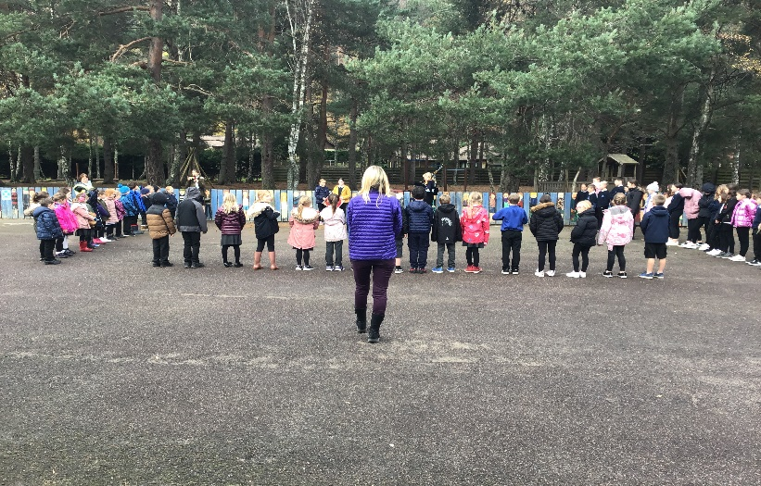

Class Learning this week
P1/2
P1/2 told us they have been reading more books this week, learning the sounds g and ea (leaf) and writing in their jotters more too. They have also been learning how to add up to 20 and 50. They have been learning about litter and they made paper hats out of recycled materials.
P3-5
This week they have been learning multiplication tables, about climate change and about the four capacities of our curriculum- Confident Individuals, Successful Learners, Effective Contributors, Responsible Citizens. They made save the planet hats and have been learning the names of colours in French. In drama they have been looking at different facial expressions and in RME they have learned about Humanism.
P6/7
On Thursday we picked and prepared tatties from the school garden. We made tattie wedges and guacamole and salsa to have with the wedges. We found out about food miles, our tatties had zero food miles! We have been learning about different forms of energy and we held debate to decide which kind of energy would be the best for our country, we chose wave power. We started learning about money with Mrs Smith. We used our creativity to make paper wands out of recycled materials.
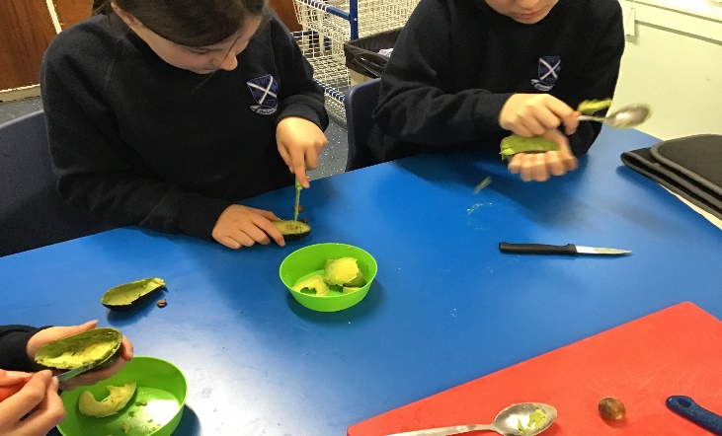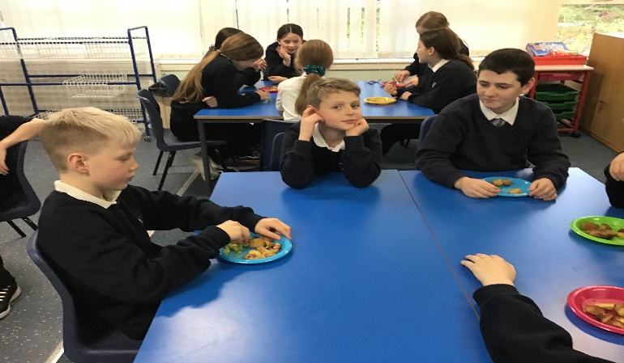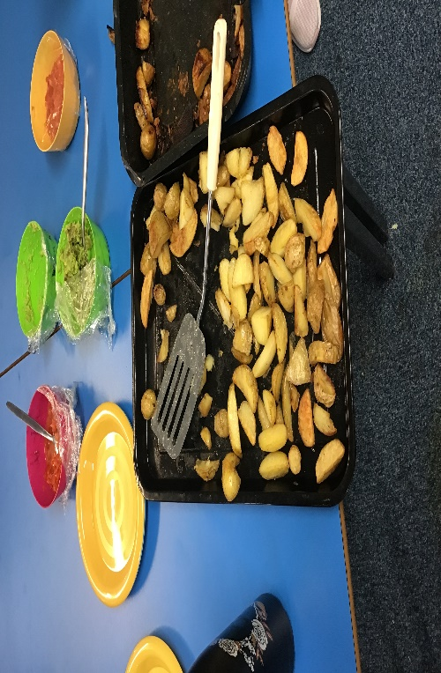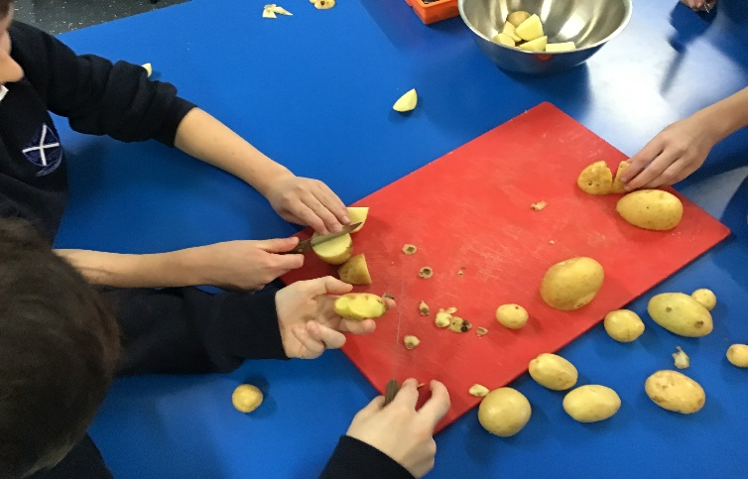
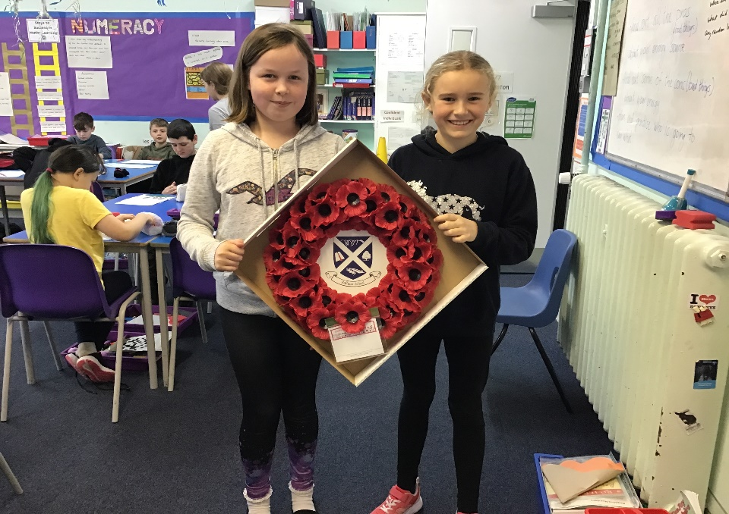
Newsletter written by P6/7
On behalf of everyone in the Ballater School and Nursery team, we wish you a pleasant weekend.

