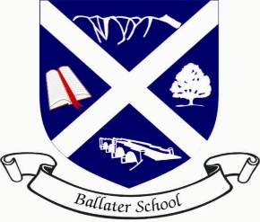
Ballater School
Weekly Update
Wednesday 17th November

This update is coming to you slightly earlier this week due to the two in-service days this week.
We have been aware of quite a few cases of Covid this week within some of our families. A reminder from NHS Grampian is keep doing lateral flow tests twice a week and more importantly to record the results of each LFD test.
If we have any cases of Covid directly in classes, a letter will be sent to the pupils in that class.
Wider Achievement Tracking Sheets
We have recently launched our wider achievement tracking system for all pupils in P1 to P7. The system has been created as an Aboyne Cluster Initiative for all 10 Primary Schools in the Aboyne network. The aim of the system is to encourage pupils to recognise that learning and achievements take many forms and they are achieving many things in their lives which are not just related to academic learning but are equally important. The trackers sheets are designed to hit specific targets at both home and school which are age appropriate but also have a page at the back to record other personal achievements.
Pupils will bring their sheets home today to be shared with parents and carers and if any of the targets have been met, they can be highlighted and dated. Other personal achievements can of course be recorded in the same way on the back sheet.
Please return the achievement sheets to school on Monday 22nd Nov. It is our intention to issue the sheets home on a monthly basis for home updates and to share your child’s progress.
Remembrance
Thank you to Abbie J, Abbie M, Hollie F, Faye, Morgan and Ruby who volunteered to represent the school at the Remembrance parade last Sunday. Very well done to Faye and Hollie who laid the poppy wreath on our behalf. These pupils certainly demonstrated our school value of respect very well.
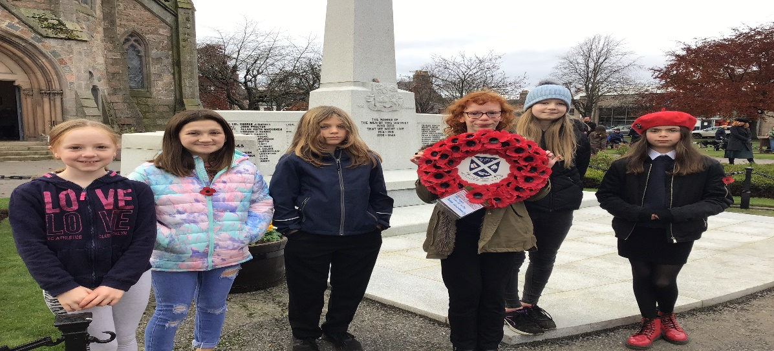

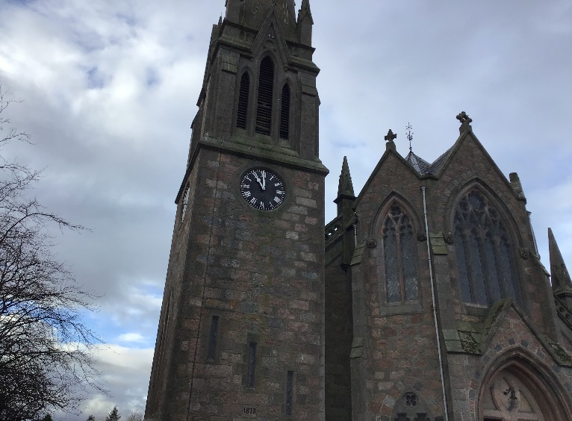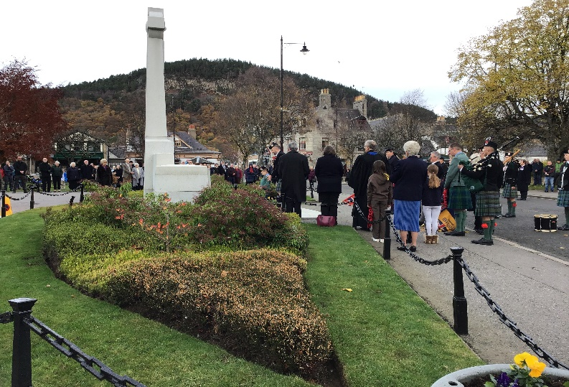
HMIe Visit School and Nursery
We are due to have a return visit from inspectors on the week beginning 29th November. The visit will take a different format and will be focusing on Covid recovery and improvements since our inspection in 2019. We understand a letter will be issued providing parents and carers with an update once the visit has been completed.
Reading
We have been carrying out some assessments on pupil progress in reading. Many pupils are making good progress, but we have identified that many pupils would benefit from reading more at home. We are currently writing a document which we hope will provide some ideas to encourage all pupils to widen their reading range. We are looking at ways that we can again start lending books from the school library to be taken home. Classes have also been looking at how they can improve the library corner in their rooms. We are looking, in conjunction with the Parent Council, at ways of widening the range of texts that are provided for pupils in school.
Children In Need
Thank you to the P6/7 class for organising our PJ and Funky hair day today. As you can see from the photos below, we had some quite unusual sights in school today.
We will give you an update next week on the total raised for Children in Need.
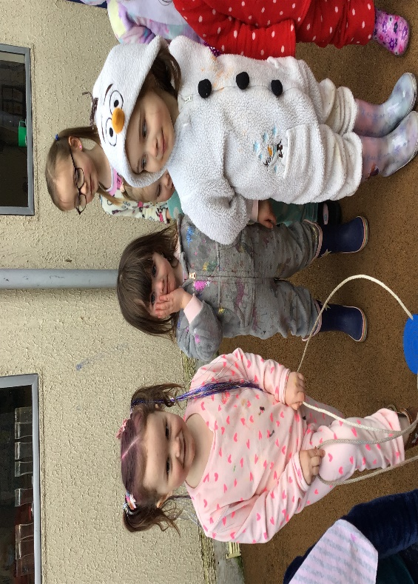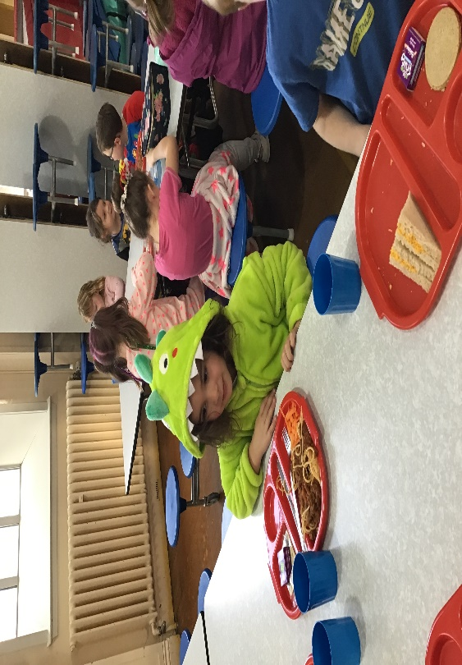
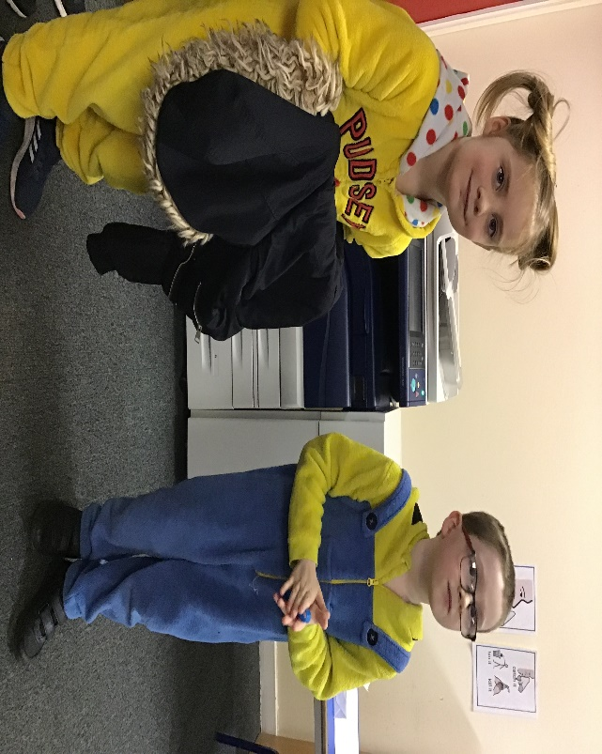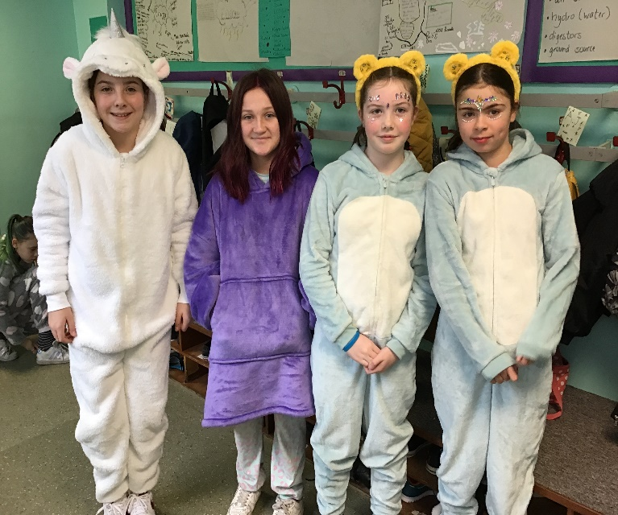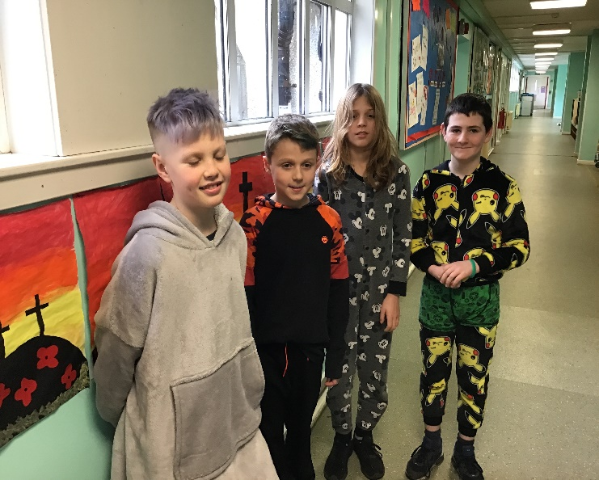
On behalf of everyone in the Ballater School and Nursery Team,
Have an enjoyable and healthy extended weekend.

