Ballater School
Weekly Round Up
Friday 5th November 2021

We hope you all had an enjoyable break and had fun with some of the Hallowe’en activities.
‘Flu Vaccinations
We have the vaccination team in school on Monday 8th November to deliver the ‘Flu vaccinations to those pupils in P1 – P7 who have consent to receive the vaccine.
The vaccine is delivered in the form of a nasal spray.
Staffing
We are delighted to have Mrs Gillian Smith join us next week. Mrs Smith will teach P6/7 on Monday and Tuesdays with Mrs Beaton teaching the class Wednesday to Thursday.
In addition, we are pleased to welcome Mrs Cruickshank back to her class in P1/2 from Monday.
Choir
We have managed to restart our school choir this week. We are restricted to rehearsing outside at present, but after our first rehearsal today it seems to be going well!
We have our first choir outing on Monday 29th November at the switching on of the Christmas lights at Hilton Craigendarroch. More details soon when we have them.

Outdoor Learning
P1/2 spent the last day of term one outdoors. We had a really enjoyable day and learned lots about our outdoor space, planting spring bulbs and about forest school skills such as using our firepit.
Below are some photos of the day.
Today P6/7 are going to be spending their day outdoors, learning about the regeneration of oak trees on Craigendarroch hill, managing risk and also how to safely use our firepit.
P3-5 and the nursery will also have these opportunities very soon.
Bananas!
We were kindly donated lots of bananas by the Ballater Pantry which pupils have enjoyed for their snacks.
We will have quite a few spare, which it would be a great shame to waste. These will be available outside the office at the end of the day. Please help yourselves!
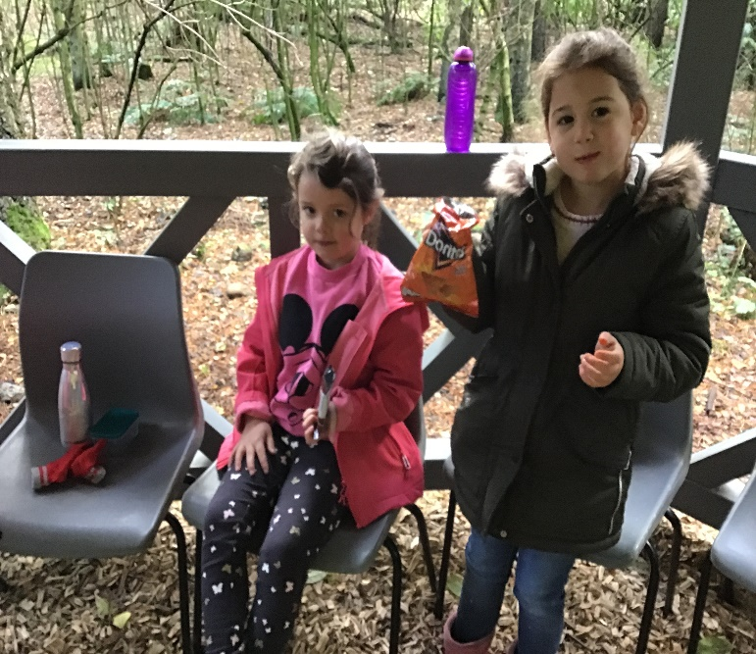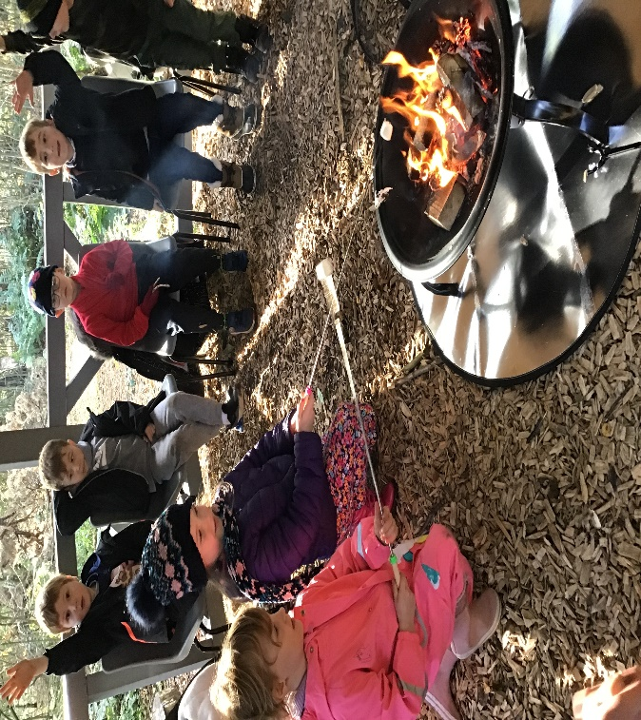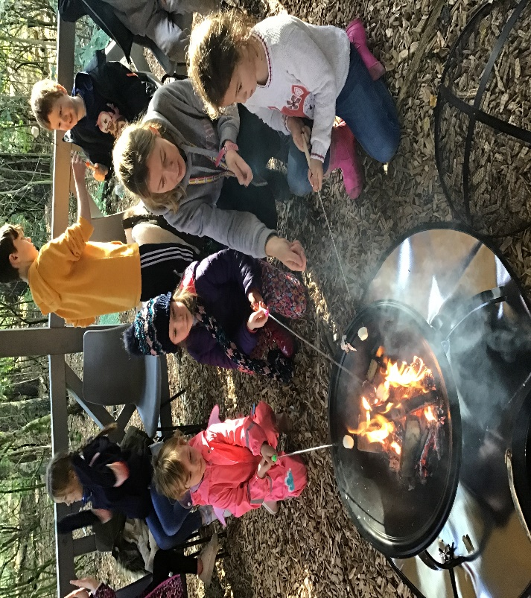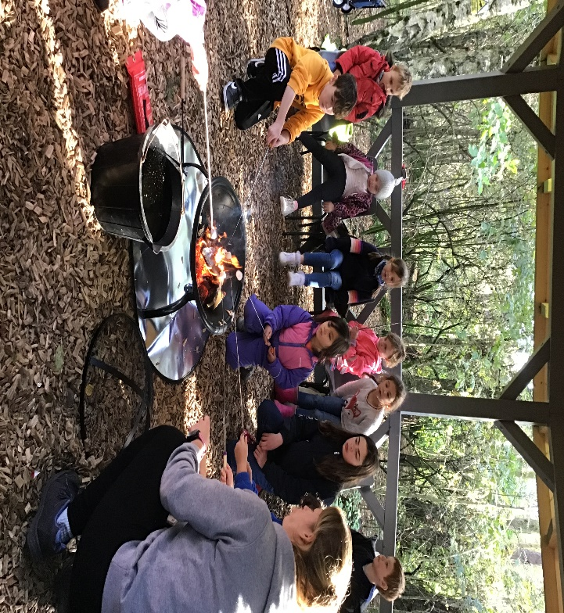
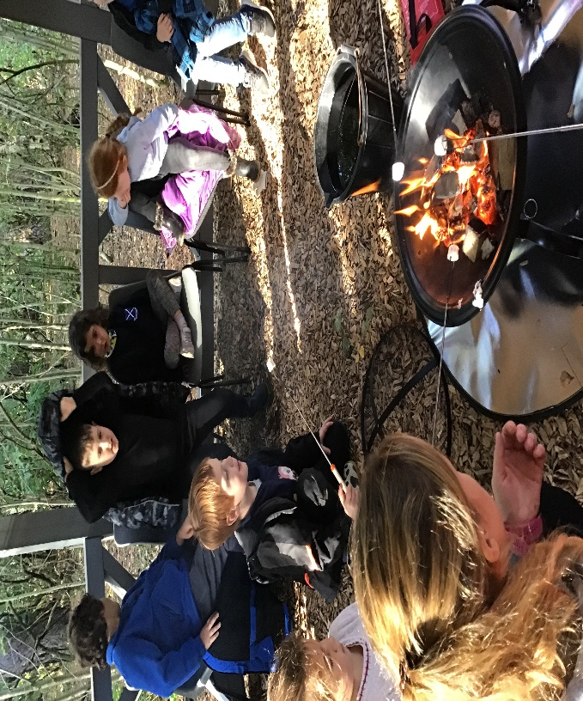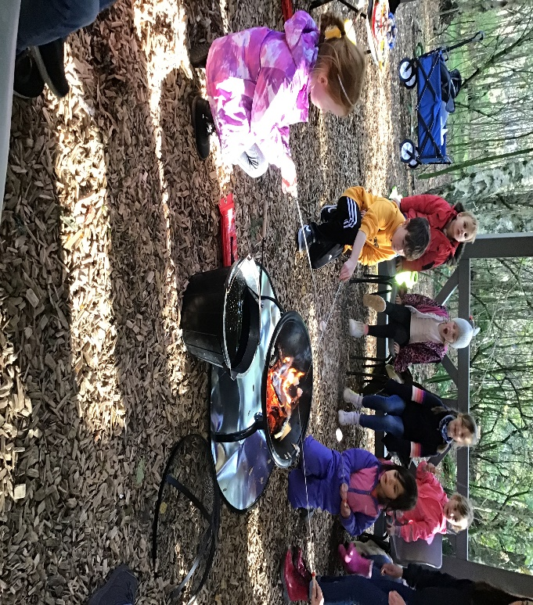
On behalf of the Ballater School and Nursery Team
Enjoy a safe Bonfire Night weekend.

