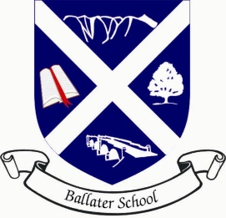
Ballater School P3-5 Term 2 Newsletter

Dear Parents
We are already in Week 3 of this term and time is passing too quickly already!
We had a very successful first term. The class works well together, and the kindness the pupils show each other continues. Our first IDL week was a great success. Everyone worked very hard, and we were all impressed with the way the pupils showcased their learning. I am already looking forward to our second IDL week which is only 2 weeks away!
This term, we are covering some different areas of the curriculum. We have included a block of drama and a block of RME, focussing on morals, fairness, and equality. Mrs. Garrett will still cover one afternoon a week. She will be focussing on times tables, as well as a block of social science, concentrating on weather and climates.
Our cross curricular topic this term is “Our Geographical/Global World,” where we will be trying to answer the question, “Is anyone too small to make a difference?” We have been learning all about global warming, climate change and what we can do to help. I am amazed at how much everyone already knew and how keen everyone is to learn more about what they can do to help.
PE will still be on Mondays and Wednesdays, subject to the odd change!
Our focus in writing this term is instructional texts and our focus in numeracy is multiplication, division and measurement.

As always, please do not hesitate to contact me if you have any questions or worries.

Kindest Regards,
Mrs. Davidson

