P6/7 Newsletter - November 2021
Welcome back to P6/7 and we are delighted to see the children back and raring to go. We are delighted now to share the teaching responsibilities. Mrs Gillian Smith, will teach the class on Monday and Tuesday and Mrs Beaton will continue to teach on Wednesday, Thursday and Friday.
Health and Wellbeing
Attached is our timetable for the term. We have PE on a Tuesday and Friday. Please make sure your child has a PE kit on a Monday and take it home for washing on Friday afternoon. Could you please make sure these are suitable for outdoor PE, i.e. joggers and suitable foot wear. This term the children will be practising their hockey skills, developing their general fitness and learning new dances.
As part of the Health and Wellbeing area of the curriculum we are learning about kindness, anti-bullying, school and personal values. We will be focussing on career pathways and thinking about skills that we need to achieve these ambitions.
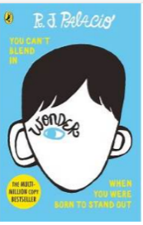
Literacy
Mrs Garrett will continue to support the teaching of writing in class. The rest of the class will be developing their report writing skills with Mrs Smith. Mrs Smith will also be developing the children reflective reading skills, through exploring the novel “Wonder” by R. J. Pallacio. We will also use some of the Health and Wellbeing themes from the book in class too. Mrs Beaton will be responsible for handwriting, spelling and reading, including comprehension.
Reading continues to be an important aspect of school and to help everyone improve we will be reading a class novel, a personal book of choice from the school library or home and each pupil will have a reading book in school. If you can, encourage your child to read anything at home-magazines, recipes, instructions, non fiction and obviously fiction if you can get them to engage. We are currently developing a reading corner in Room 5, if you have any magazines or books that you have read and wish to donate these would be gratefully received.
Numeracy and Mathematics
Mathematics
Mrs Smith will be responsible for teaching mathematics. This term we are focussing on money and 2D and 3D shape. We will be developing life skills using money problem solving. If the opportunity arises, please encourage your child to handle and practise using money. Perhaps at a local supermarket or online.
Numeracy
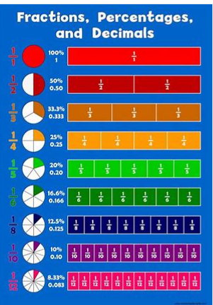
Mrs Beaton will be focussing on rounding and estimation. We will them move on to looking at fractions, decimals and percentages. If you wish to reinforce what the children are learning in school they could access ‘top marks maths’ online and search for the topic we are covering in class using the search function.
As always, please continue to practise times table and any of the four number operations (Addition, subtraction, multiplication and division) at home as this will help your child’s confidence.
CC
Our Cross Curricular learning this term will be based around COP 26 and looking after our planet. The children will learn about different types of energy and how they can make a small difference in their daily lives and how this can help battle climate change. After this, we will have a short focus on the Christian celebration of Christmas.
And Finally
We will still be using Google Classroom as a means of home/ school communication and this has been set up. Please try to access this resource as we intend on sharing what the children are learning about in class periodically.
Please get in touch if you have any questions about your child’s learning or experience at school. Leave a message with Jenny in the office and we will get back to you.
We are really looking forward to working together, with your amazing children and hopefully once restrictions lift, with yourselves too.
MRS BEATON & MRS SMITH

