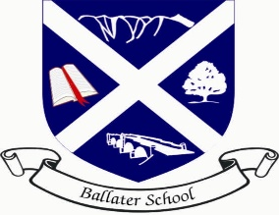
Ballater School
Weekly Update
Friday 3rd December 2021

Well, it is safe to say this week has not exactly gone to plan! We hope everyone is now safe, warm and reconnected with power and communications, it has certainly been a challenging time for everyone.
We started back on Wednesday giving everyone time to discuss and reflect on how they were feeling and to recount some of the events of the last week.
This was planned to be our IDL week in school. We have started IDL now and it will run to next Tuesday when we will showcase the learning then. We will include pictures with you in next week’s update.
We were disappointed to have to postpone our visit from the school inspectors which couldn’t happen due to the power situation. We understand this will be rescheduled for January 2022.
Trees
Also due to the weather and disrupted week we have been unable to plant any of the trees which we have been donated. We will do this next week and all pupils will be issued with their complimentary tree sapling at the same time.
Christmas arrangements
Pupils in all the classes have been planning what they would like to do in school to celebrate Christmas. Classes will issue dates next week and information about arrangements. We are still working within Covid mitigations, so we will be doing things slightly differently from previous Christmases. We have some exciting ideas being planned at present!
P1/2 Reading
We have been catching up on P1/2 reading this week after we missed some days at the beginning of the week. We will not be sending reading home this weekend as we felt families may still be readjusting to normal life after the weather events of last weekend. We will send reading home next week as usual.
Choir
We are delighted that Hilton Craigendarroch have rescheduled the switching on of their Christmas lights. The event, postponed from this week, will now take place on Monday 6th December at 4.30pm at the main entrance area of the resort. Members of the choir have been issued with an updated information letter.
P5-7 Skiing
We recently asked P5-7 families whether they would like us to look into the possibility of organising a ski week in January. Due to insufficient numbers, it is not going to be possible to operate this trip next term. We hope to return to Glenshee in 2023 with our school.

As always, have an enjoyable, safe and warm weekend.
Ballater School and Nursery Team.

