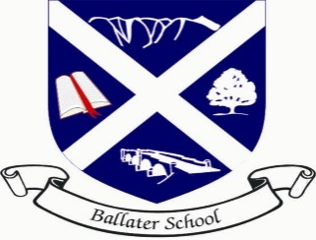
Ballater School Update
Friday 11th March 2022

Firstly, our apologies for the lack of update last week. This was due to the lack of capacity due to high numbers of staff absence.
We are delighted to have almost all our staff back to work and also seeing many of our pupils returning back to school too. It has certainly been a very difficult few weeks for everyone and we look forward to having full classes again.
Thank you to all our families and staff who have worked so hard to follow the guidelines and try to help keep us all safe.
Twitter Accounts
Unfortunately, the launch of our class Twitter accounts has been delayed due to all the disruption. We hope to be sharing this information with you all in the next week or so.
Tech Club
We are going to be starting an afterschool club for pupils in P4-7 to have some fun learning some technology skills such as coding, animation, movie making and other activities suggested by the club members.
The club will run on a Tuesday from 3.15pm until 4.30pm starting on Tuesday 22nd March with a planning and introduction session.
A consent letter with full information will be issued today. Please return these by the date shown if your child would like to attend.
Pupil Reports
Teaching staff are currently working hard on writing pupil reports. Pupil reports for pupils in P1-P7 will be issued on Thursday 31st March.
We will arrange parent/teacher discussions when we return after the Easter holidays.
Community Litter Picking
We have been asked to share information about a regular litter pick in the village.
“Ballater CAN decided to promote a monthly (second Saturday of the month) Community Litter Pick for adults and kids alike starting this month, ie this Saturday From 14.00 (to 16.00) . It would be great to see you if you can. “
Choir
We have been invited to join in the Platinum Jubilee celebrations in the village in June. Our choir has been invited to sing at some part of the weekend events.
Choir will start again on Friday 18th March at 1.00pm to start planning what we might sing at this special event. We look forward to seeing lots of members again.

P7 Transition
Our P7 pupils have had their photographs taken this week for their National Entitlement Cards (Young Scot) which they will need when they move to the Academy.
A small group of our P7s are to be visiting Aboyne as part of a short, extended transition visit on Monday 14th March.
The whole cohort will start transition visits shortly after returning from the Easter holidays. We will share this information shortly.

We wish you all a pleasant and restful weekend
The Ballater School and Nursery team.

