Ballater School
Weekly Update
Friday 27th May 2022
We are all busy in school at the moment preparing our learning for the IDL presentations on Wednesday morning next week. We will share the work with all parents via a Sway or something equivalent.
Jubilee Events
Thank you to everyone who let us know about those children attending the choir events. We are busy organising our Jubilee sashes for the choir to wear at their forthcoming events next week.
We were delighted to receive the letter pictured below this week recognising all the hard work all the children put into their flag designs.
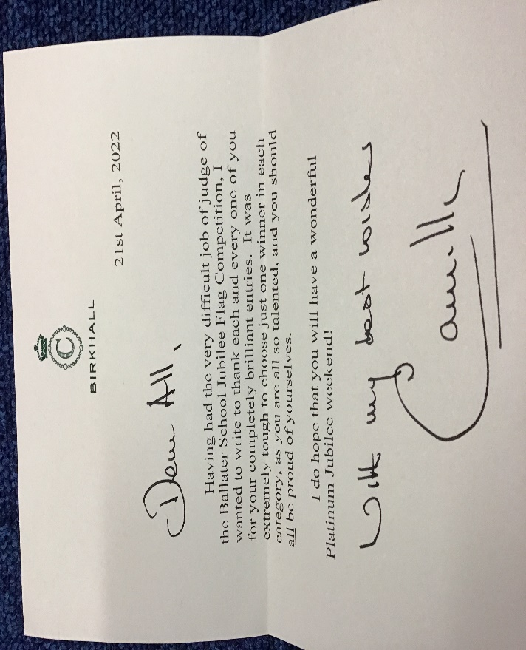
We are pleased that all our flag design winners can attend a short ceremony recognising their achievements on Sunday 5th June as part of the jubilee celebrations.
School Jubilee Celebration
Pupils shared their ideas on how we could celebrate the jubilee in school and we have come up with the following. We will hold a celebration event for pupils in school on Wednesday 1st June. All pupils and staff are invited to wear clothing with a red, white and blue theme for Wednesday. We will be doing some craft activities and then we will all gather in the hall to enjoy a small tea party. We will be serving cake, crisps and juice with dietary requirements taken into account.
Jubilee Holiday
A reminder that the school and nursery will be closed on the following dates as part of the Platinum Jubilee celebrations:
Thursday 2nd June
Friday 3rd June
Monday 4th June.
Rotary Quiz
After an absence of two years a team of our P7 pupils took part in the Aboyne Rotary quiz on Tuesday. The online quiz was very competitive and we were delighted that our team ( Ruby, Kara, Morgan and Tavia) came second out of 10 teams. They were pipped by one point by a team from Tarland. Well done to our team for representing our school so well.
Nursery Staffing
Claire Cameron was appointed as a trainee Early Years Practitioner in 2020. Claire has successfully completed her training, indeed finishing much quicker than was expected by the Council. We are pleased that Claire has now been appointed as Early Years Practitioner to remain with Ballater Nursery. It has been great to see all her hard work pay off and even better that we have been able to retain her in a post in our nursery. We wish Claire well in her new role.
Thank you
Today we said farewell and thank you to Ashleigh Smith in her role as our mid-day refresh cleaner. This was a role created as part of our Covid mitigation measures. Aberdeenshire Council have decided that we no longer have the need for this extra cleaning. We wish Ashleigh well in her future.

School and Nursery Open Doors Afternoon
We are holding an open doors session on Wednesday 22nd June from 3.30pm – 5.00pm. The school and nursery will be open for everyone to come and see what our classrooms look like and what we have been doing over the last term. P7 pupils will be serving hot drinks and cake for £2 in the hall as part of their fundraising focus and the ladies from the gardening team will be in the garden to share the work that has been done there.
We look forward to welcoming you into the school on the 22nd June.

Wishing you all a pleasant weekend- let’s hope for some warmer weather.
The Ballater School and Nursery Team

