Ballater School
Weekly Update
Friday 6th May 2022

Firstly, apologies for the lack of weekly update last week, this was due to staff illness.
We have had a very busy week with both the P7/S1 and nursery/P1 transitions getting underway in earnest. Feedback from both sessions has been very positive ad we look forward to the next events in the weeks to come.
New P1 and P1 Sight Checks
A reminder to please return the consent firms for the sight checks that are taking place in school next week.
P1/2 Water Bottles
A polite reminder please that pupils should only be bringing water in their bottles each day. We have had a number of spillages of juice recently resulting in school resources being spoiled and thrown out as the juice has stuck pages together etc. Thank you for your support in this matter.
P7 Fundraising
We were delighted to see our P7s last week using their World of Work skills to organise and manage a very successful fundraising venture in the form of the daffodil sale. The pupils took complete ownership of this activity and in the process began to learn about the roles and responsibilities involved in running a business. The team raised around £100 which is a great boost towards their final total.
P3-5
As part of their cross curricular learning, the class have been busy learning about supporting the needs and wants of people in our community. They have identified that due to the rising cost of living, many people are finding it difficult to afford basic needs such as food. The class have gathered a donation to support some of the local foodbanks/pantries to help with these needs.
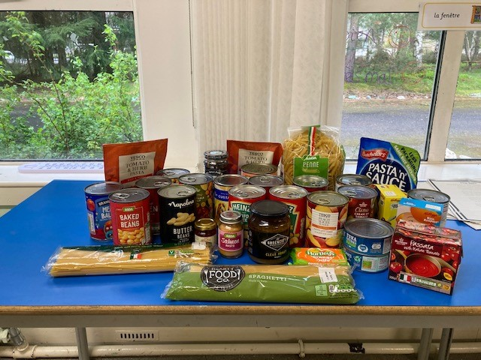

Jubilee Celebrations
Congratulations to the following pupils who had their designs selected for the community Jubilee Flag: Morven Tammi – nursery, Ally Dey – P1/2, Cooper Muir- P3-5 and Tavia Bergman P6/7. The designs are away being processed to be made into our community flag.
Our choir, which numbers 24 pupils, has been very busy rehearsing for the two jubilee events we have been invited to attend. We do not have final details yet, but we will be singing at the lighting of the Jubilee Beacon on the evening of Thursday 2nd June – possibly around 9pm- tbc and we will also be singing at the Jubilee afternoon tea during the afternoon of Saturday 4th June.
We are excited to be welcoming a music teacher from Aberdeen next Friday morning to support us with the Jubilee song.
We will send out further details as soon as we have the information.
Seesaw Privacy Notice
A reminder to return the privacy notice forms for seesaw as soon as you can to allow us to sign your child up to use this communication system. We will issue instructions in the next couple of weeks on how to use the app.
Parent/ Teacher Calls
A reminder if you would like to discuss any aspect of your child’s recent report, teaching staff will be available from Monday 16th to Friday 20th May. Please contact the school office to arrange a convenient time.

We wish you all an enjoyable weekend
The Ballater School and Nursery Team

