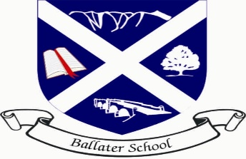
Ballater School
Weekly Update
Friday 10th June 2022

Well, what a week we have had! We hope everyone was able to enjoy the long weekend and the lovely weather was definitely a great bonus. We were very proud to have some many members of our school community involved in the jubilee events in the village. Thank you to all the pupils for taking part and also to Mums and Dads who supported the children to attend.
A Sway with pictures and information about our final IDL learning and the Jubilee events can be accessed on the link below:
https://sway.office.com/QVLeoOKWPOCcdcJb?ref=Link
Sports day.
We were delighted to be able to hold sports day again this year and what a great time we had, very much helped by the lovely weather.
Well done to every child who took part for showing ambition, achievement and at times great resilience.
Thank you to the Parent Council for supplying the drinks and fruit and thank you to all our spectators who helped create a positive atmosphere for the athletes.
Congratulations to Tullich who were our winning house
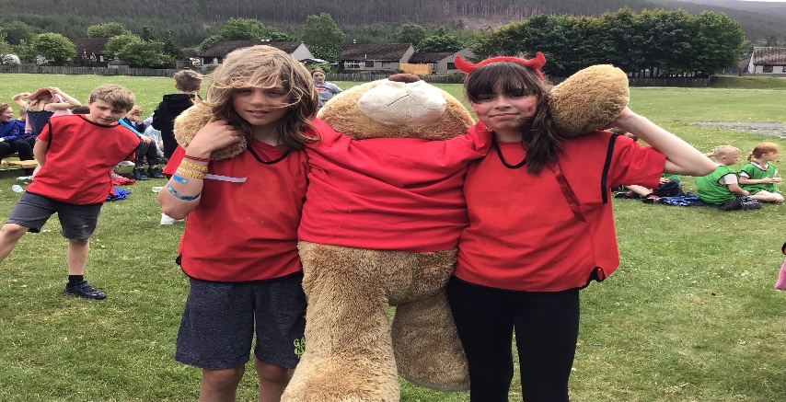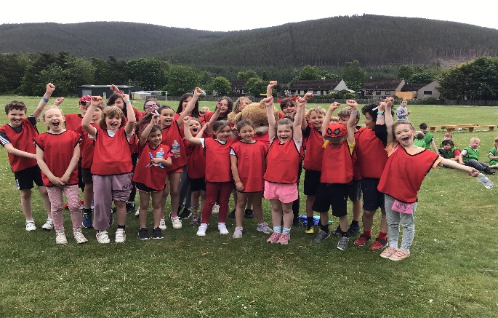
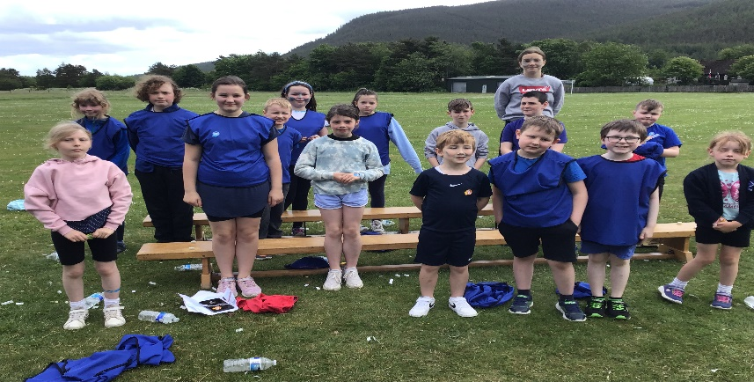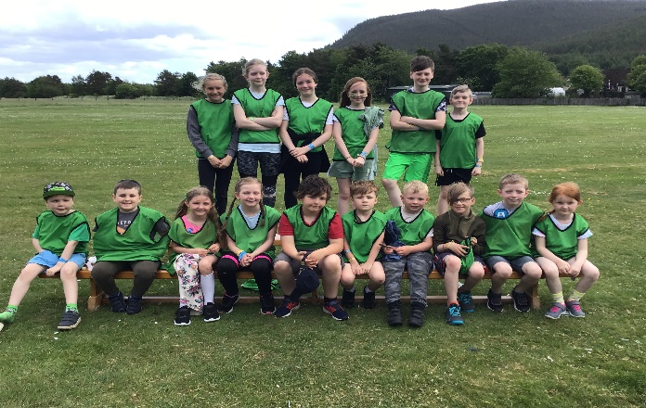

P6 Cycling
A reminder that our P6 pupils will need to have their bikes and helmets in school every day next week to take part in Bikeability Level 2 road training. A timetable of the plans was sent out earlier this week. Pupils will be bringing home the booklets they will need to study tomorrow.
Transition Events
P7/S1- The P7s will be attending Aboyne Academy on Thursday 16th and Friday 17th June for their final two transition days.
Nursery/P1 – Our new P1 pupils are to be meeting their new buddies (P6 pupils) and coming through to the lunch hall for lunch on Thursday 23rd June.
We are also delighted to be welcoming some new children into the nursery in the next few weeks ready for them starting with us in August.

Wishing you all a restful weekend.
The Ballater School and Nursery Team

