Ballater School
Weekly Update
Friday 24th June 2022

It has been an action-packed week this week. We have enjoyed the summer weather with class trips, cycling and our open afternoon.
Thank you to everyone who came along and gave us such positive feedback about our school. We look forward to inviting our community in again next session.
Trips
P1/2 enjoyed a great day out to Balmoral on Tuesday, learning lots about the wildlife and plants and finding the exhibition very interesting, the Queen’s clothes were a particular hit!
P7 had a wonderful day at Knockburn Loch yesterday spending most of the day in the water as the weather was so warm. The loch was a balmy 17 degrees!
We will compile a selection of photos form all the class outings into a Sway for the end of term.
Cycling
Our P6 pupils have been working very hard to learn and develop their road cycling skills this term. Yesterday, the pupils who have completed the training, were assessed on their learning and all did very well. Certificates will be awarded at assembly next week. Well done P6.
Transition
We were delighted to welcome our new P1 pupils in for their first school meal yesterday. The P1s were supported by their P6 buddies who will continue to support them after the summer break.
Also yesterday, all the pupils in school took part in a “Moving On Hour” which gave pupils a chance to move into their new classroom and meeting the other members of their class.
Assembly Our assembly themes have been based around water over the last couple of weeks. We have learned about World Ocean Day and also how we can keep ourselves safe when in and around water as part of water safety week.
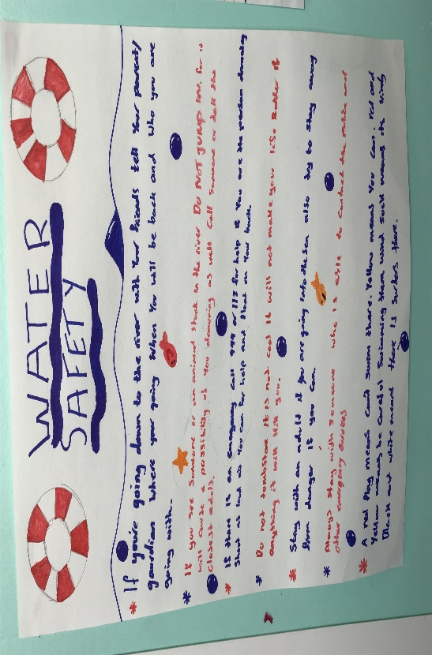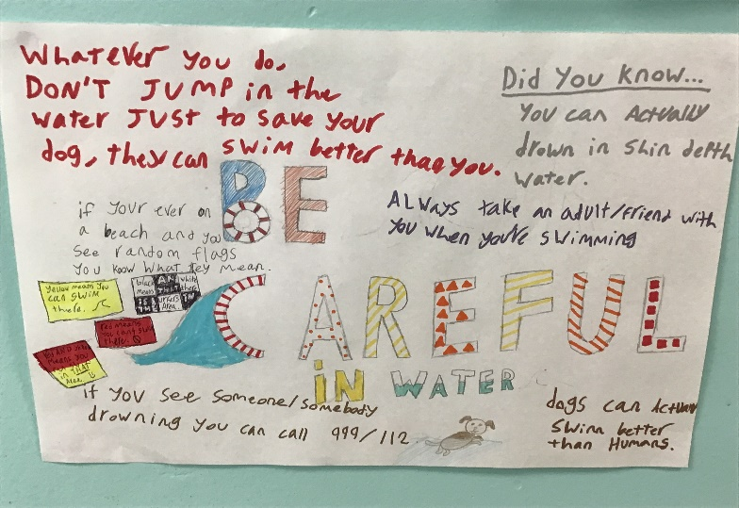
It has been super to be presenting certificate again to pupils who have worked hard to display our school values.
In addition, well done to Harris and Max for sharing some out of school achievements, Harris for winning lots of Highland dancing competitions and Max for achieving a yellow belt in Soo Yang Do.
Our focus skills for everyone to aim for is showing empathy for others “I can help one of my peers”
School Uniform Recycling
Thank you to everyone who donated preloved school uniform items. We still have a lot of polo shirts and other items free to good homes. We will put the clothes rails outside the office from 2.45pm each day for people to help themselves to.
Outdoor Learning
As well as enjoying lots of great outings, pupils have been working very hard with our gardening team to develop our school garden. We were delighted to receive a certificate marking our achievement reaching Level One of the RHS School Gardening Awards scheme. Thank you to the ladies of our gardening team for all their hard work, great ideas and enthusiasm in making our garden such a beautiful place with great food grown for us all to enjoy.
P3-5 are joining up with community volunteers this afternoon to take part in a village litter pick.
Nursery Staffing
We are very sorry to be losing Jamie McCallum as Early Tears Senior Practitioner from our nursery. Jamie is moving onto become an inspector with the Care Inspectorate. We wish Jamie well in her new post and would like to thank her for the tremendous work she has done to support and develop our nursery. The post will be advertised in the next week, and we will keep you updated with the recruitment process.
End of Session Assembly
A reminder, if you would like to attend the end of term outdoor assembly at 11am next week, please email us on the address below to book your seat. Thank you to all those of you who have already done this.

Wishing you a restful weekend, one more week to go!
The Ballater School and Nursery Team.

