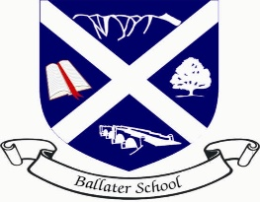
Ballater School
Weekly Update
Friday 16th September 2022
At the end of our fourth week of our new session we are still yet to have a “normal” week in school. We were delighted to host the children and staff of Crathie School for two days and we hope they enjoyed their time with us.
We were pleased to see some of our senior class represent our school and community on CBBC Newsround programme, speaking about their memories and feelings about the death of Her Late Majesty the Queen. Well done to everyone who volunteered and took part in the filming last week.
Our senior class took time on Monday to place a floral tribute, on behalf of our school community, on the Church Green in the village on Monday.
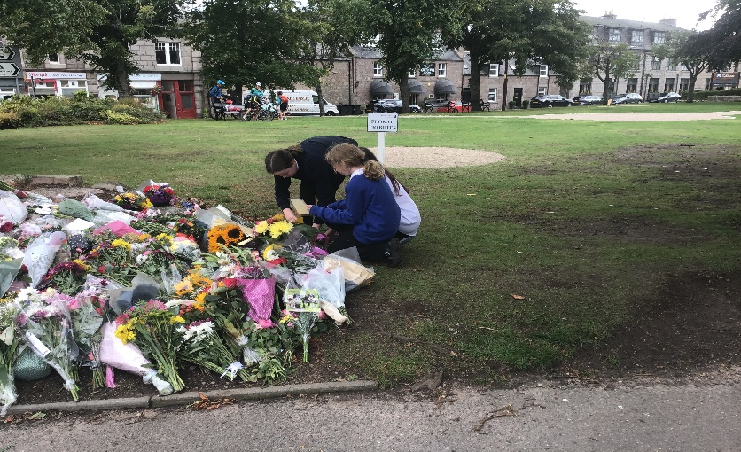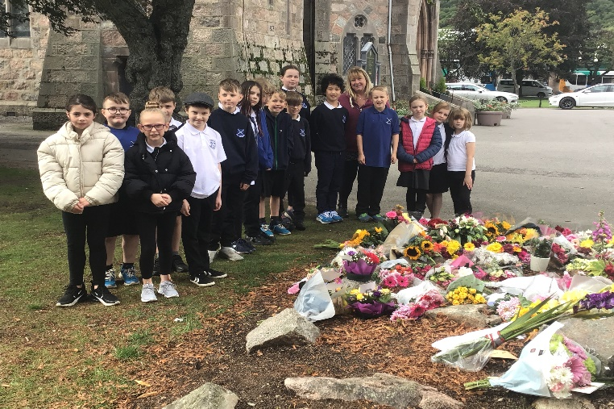
Visitors to our school
We were delighted to welcome Mike Mungo and Mason Robbins to our school yesterday. Mason is the education officer for the Shetland Space Centre project at Saxavord Spaceport.
Mike Mongo | astronaut teacher
Mike spends his time working in schools and camps across the US, encouraging young people to think how STEAM (Science, Technology, Engineering, Art & Maths) affects their daily lives and how they could have a career or a life in space. Tomorrow’s jobs are in space – learning this gives today’s children critical competitive advantage for tomorrow’s space jobs. They discover what it takes to pursue traditional and non-traditional careers in space, including space artists, space trades, space athletes, space gamers, and space YouTubers.
As well as inspiring young people, Mike has just achieved a lifetime’s ambition by being accepted onto the SpaceX Blue Origin mission so he will, at the age of 57, finally be going into space later this year as an astronaut.
It is fair to say Mike generated an enormous buzz across the school with many pupils telling us they would like to be astronauts. We hope their visit has helped our learners think about the possibilities of the world of science, and what opportunities this could hold for them in the future.
Names on belongings
Thank you to everyone who has taken the time to write their child’s name on their personal belongings. If you have not yet managed to do this, please try to ensure items such as sweatshirts, t-shirts and PE items are named to avoid them getting muddled up and lost.
Pupil Photographs
We are aiming to have the pupil photographs taken in school time next week with Aboyne Photographics. These will be taken on days that the weather is suitable.
Seesaw
We are pleased that most pupils and families are now connected on the SEESAW app. The purpose of the app is to share home learning tasks and updates in learning. We are aiming to have a least weekly posts shared by the pupils/staff to keep you up to date with what is happening in school.
We are not permitted to use SEESAW as a general communication method. If you need to get in touch with a member of staff, please contact the school office in the first instance.
Parents Portal
Some good news, we have now got every family in the school logged on to Parents Portal and our census update has been completed! Thank you very much to you all for getting to grips with this new system which now it is up and running should make administration tasks much more straight forward and also reduce the use of paper.
Gardening Club
Our gardening team has restarted their weekly sessions with different classes. Despite the weather, the team have been busy harvesting produce from the school grounds and tidying up the growing areas. Thank you to Laura and Nicole for their ongoing support.
P7 Toast
We have a really organised P7 team this year who have hit the floor running in terms of their fundraising this year. A reminder that they have fresh, buttered toast on sale each Friday morning break.
And Finally
A reminder, that due to the State Funeral of Her Late Majesty the Queen, Ballater School and Nursery will be closed to all pupils and staff on Monday 19th September.

Wishing you all a restful weekend
The Ballater School and Nursery Team

