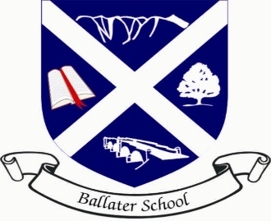
Ballater School
Weekly Update
Friday 9th September

It is with great sadness that we all learned of the death of Her Majesty the Queen last night. We have been taking some time in school today to give everyone the chance to talk and share their memories, stories and emotions at this sad time. We will be holding a special school assembly this afternoon to celebrate the life of the Queen.
As shared in a message this morning, we will be hosting the pupils and staff from Crathie School for the next 10 days or so. It has been lovely to welcome them all to our school this morning and we are looking forward to them joining in with the life of our school.
Pupil Photographs
Due to potential disruption around royal arrangements, we are postponing our pupil photographs with Aboyne Photographics until the week beginning Monday 19th September.
Personal belongings/clothing
We are encountering quite a few lost sweatshirts, tee- shirts, PE shorts, and other pieces of school uniform and belongings because they are not named.
We would be extremely grateful if you could take the time to name your child’s clothing especially PE kit. In the event of an item going missing, without a name we cannot guarantee the item will be returned.
Wishing you all a peaceful weekend

The Ballater School and Nursery Team.

