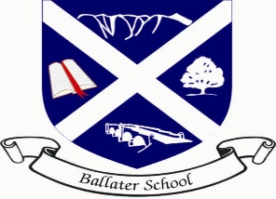
Ballater School
Weekly Update
Friday 11th November 2022

What a varied and interesting week we have had! You will see from the information below that there is a lot happening in school as well as all the daily learning.
Gardening Club
We were delighted to have 3 special visitors attend assembly this week. Nadine Stuart and Evelyn and George Baikie joined us from the Ballater Horticultural Society to present us with a cheque for £250 to be spent on future gardening work in our school.
In addition to the cheque and certificate from Ballater Horticultural Society, we received a certificate and book to mark the school achieving Level 2 of the Royal Horticultural School Gardening Awards.
We are delighted that all the hard work of our gardening team and the pupils has been recognised by both organisations and we are already looking forward to the growing season for 2023!
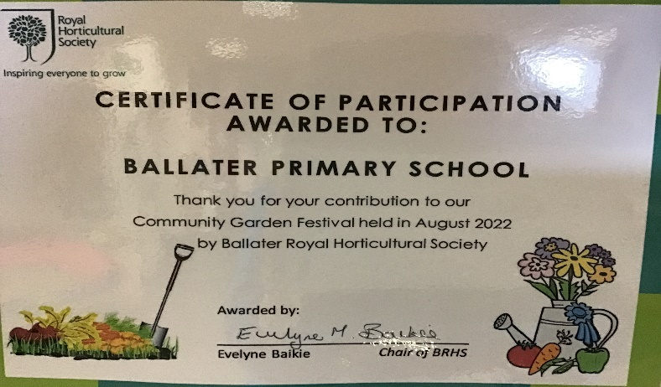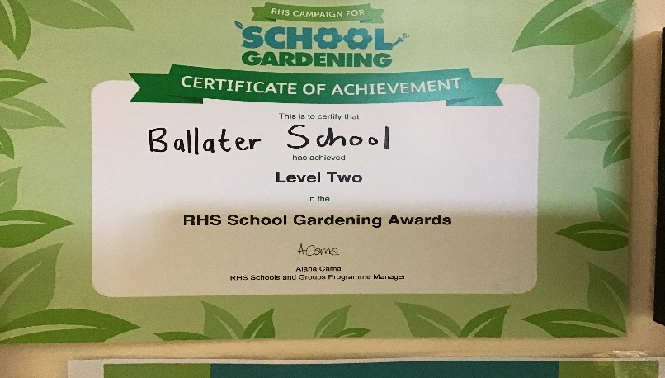

Parent Council Tea Towels
A reminder that you can place advance orders for the forthcoming Parent Council tea towel. It is looking great!

Assembly
This week as well as receiving our gardening money and certificates we were learning about the significance of poppies at this time of year. P1/2 and P3/4 have done some lovely artwork on the theme of remembrance poppies.
We held a whole school 2-minute silence today at 11am and some of our P7s will be attending the community Remembrance service on Sunday morning where they will lay a wreath on behalf of our school community.

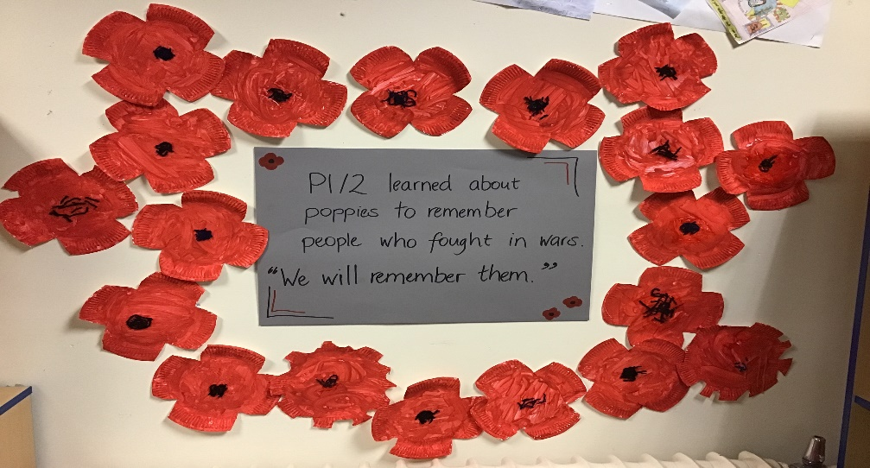

Cooking Club
It was super to see cooking return as an activity for our pupils this week. P5-7 made lots of amazing healthy things using produce from our school garden. Next week P3/4 will be cooking.
Ski Week
We are in the process of sending out paperwork to P5-7 pupils for ski week in January. We are hoping to go to Glenshee for the week beginning 16th January 2023. The trip is dependant on there being snow and enough pupils wanting to attend to make the trip viable. Please look out for the documents in an email coming in the next day or so.
Choir
It is a busy term for our choir. We sent out letters to all those children in the choir about the forthcoming TECA concert.
Additional choir events are likely to be:
Saturday 26th November – Ballater Winter Festival – tbc
Monday 28th November – Craigendarroch Lights Switch On – 5.30pm
Sunday 11th December – TECA Evening Express Concert – 2pm
Friday 23rd December – Church Service – tbc
Christmas Fair
We are already busy planning and starting to make goods for our forthcoming Christmas Fair on Saturday 3rd December. The pupils are excited to be using their creative skills and also business skills that they developed during one of our IDLs last session. The fair will be the major fundraiser for the school to help with costs like school trips, resources for cooking, gardening and other extras that we use throughout the school year.
We look forward to seeing our community at our fair to enjoy some refreshments, purchase some goods and just take time to see everyone again.
I-Pad Music
Pupils in P3-P7 took part in their first iPad music session this week with Mr Watts from Aberdeenshire’s music service. Lots of interesting sounds and learning going on!
In-Service Days
A reminder that we have two in-service days next week on Thursday 17th and Friday 18th November. The school and nursery will be closed to all pupils on both these days to allow staff to work on development priorities.
Breakfast Club
A reminder, booking for our forthcoming Breakfast Club week needs to be with us by Tuesday next week. Breakfast Club will take place for the week beginning Monday 21st November.
Cost of Living
We are acutely aware of the impact that the cost of living is having on everyone. Often at this time of year Mrs Duckworth gets asked by community or other charity groups if we have any families that we think could benefit from some support either food, clothing, or other goods. In the past we have found this quite difficult to identify families as we do not want to offend but obviously, we also do not want to miss any families out. To help us sign post any families that would like to receive any offered support we would ask that if your family would benefit from a little extra help, you fill in the Forms survey on the link below.
Information shared will be treated in the greatest confidence and we will only share information with charities or providers that need information to distribute goods.
https://forms.office.com/Pages/ResponsePage.aspx?id=BpPZ_i1NCUSVndDttzBKC_oZihCN7iZJlgUhV5yUcrBUMVhNTDE3SkVaT1BUWEVKRUdJMFhDS01SRy4u

And finally, a reminder that we are hoping to have some fun and raise a little for Children in Need on Wednesday next week. Please let us know if your child is permitted to have their face/ nails painted and the dress theme for the day is “Colourful and Creative!” We look forward to sharing some photos of the event with you!

Enjoy your weekend
The Ballater School and Nursery Team.

