Ballater School
Weekly Update
Friday 16th December 2022
It is fair to say winter has well and truly arrived. Thank you for your forbearance with closures and changes to our usual routines. We hope we can make it to the end of term without any more disruption.
Choir
We are so proud of our choir! They did amazingly well performing at TECA last weekend. Despite being quite a few members short, the 17 children sang well and were a great credit to our community. I know that the children and staff felt a huge sense of achievement after some nerves beforehand. Well done! The choir have two more engagements before the end of term at Sluiemhor on Thursday 22nd December and at Glenmuick Church on Friday 23rd December.
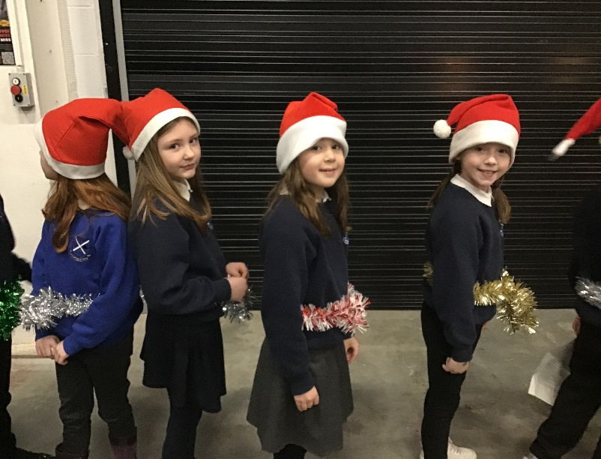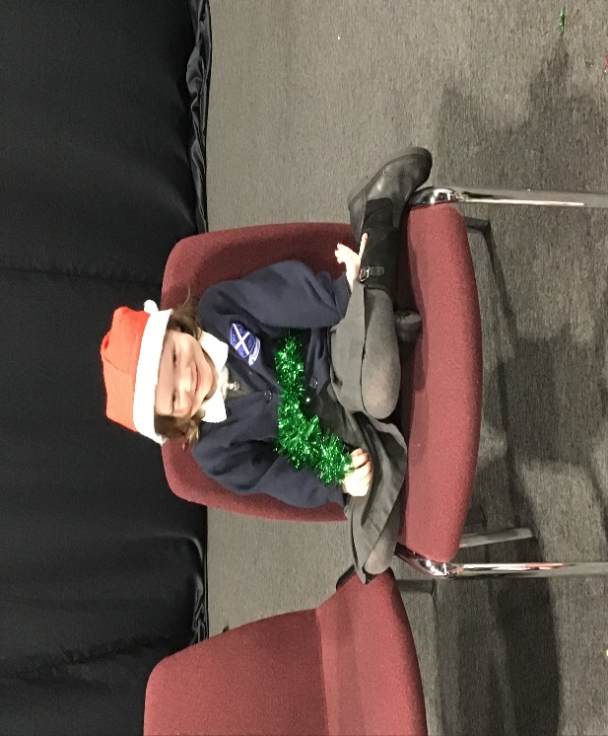
IDL
Due to the disrupted week, we have had to change our IDL plans. Pupils will now be sharing what they have worked on so far to the other classes. We will invite parents in for our next IDL next term.
Christmas Lunch
We all enjoyed a lovely Christmas lunch together in the hall today. Thank you to Helen and Wethenee for the lovely food and to the Parent Council for the crackers.
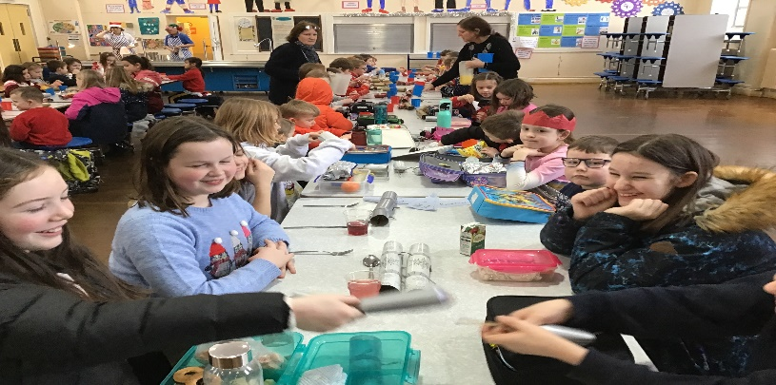

Assembly
We were thinking about the importance of disposing of our rubbish and recycling in assembly this week. We enjoyed the new story from Sabine Muir about the sea creatures that find their ocean is full of our rubbish. Also, this week, Max told us about his achievement, he successfully graded onto a Yellow Senior Sooyang Do martial arts belt. He also broke a bit of wood with his feet – well done Max!

Christmas Film
We are looking forward to going to Victoria Hall on Wednesday 21st December as a whole school to watch Clifford the Big Red Dog. Ice cream orders are ready, and we have an alternative for those unable to eat dairy foods. Thank you to the Parent Council for organising and funding this treat for the whole school. All P1-7 children will be taken back to school at the end of the film. Nursery parents should collect their child from the Victoria Hall at the usual nursery pick up time.
Christmas Parties
The nursery party and P1-7 parties will both take place on Thursday 22nd December. Nursery will issue their information for parents via the usual communication methods.
The P1-7 party will take place during the afternoon of the 22nd. Pupils should bring party clothes with them on Thursday to change into after lunch. Thank you to the Parent Council for supplying food at the parties.
Friday Toast
As an end of term treat the P7s will be selling waffles on Friday 23rd December. They will be £1 per waffle with a tipping of either syrup or chocolate spread. There will be dairy and gluten free waffles available. Please let us know in advance if your child would like to order a “Free From” waffle.
Church Service
We will finish our term with our church service at Glenmuick Church on Friday 23rd December. The service will start at 2.00pm. Pupils should wear school uniform but can add Christmas hats etc if they wish. Parents and friends are welcome to join us at the service. Pupils whose parents are attending the service may be dismissed form the church when the service finishes. Please let the school office know if your child will be dismissed with an adult from the church. Those children not being met at the church will be escorted back to the school and dismissed at the usual time.

Wishing you a peaceful weekend.
The Ballater School and Nursery Team.

