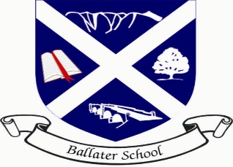
Ballater School
Weekly Update
Friday 2nd December 2022

This week has flown by with everyone really busy preparing for our Christmas Fair tomorrow. We are all very excited to, at last be able to host a community event again and we look forward to welcoming you into the school tomorrow.
Staffing
This week we said goodbye to Kirsteen Higgins in the nursery who has now started her new post in the city.
Jenny Anderson and Aileen Eady leave us on Tuesday, and we wish them well in the next stage in their lives. Helen Johnstone and Wethney XXX will be taking over in the kitchen from Wednesday for the meantime.
Christmas Fair
Our Fair will run from 10.30am until 1.00pm tomorrow. Below are some pictures of a small selection of goods, handmade made pupils from nursery to P7, available at bargain prices.
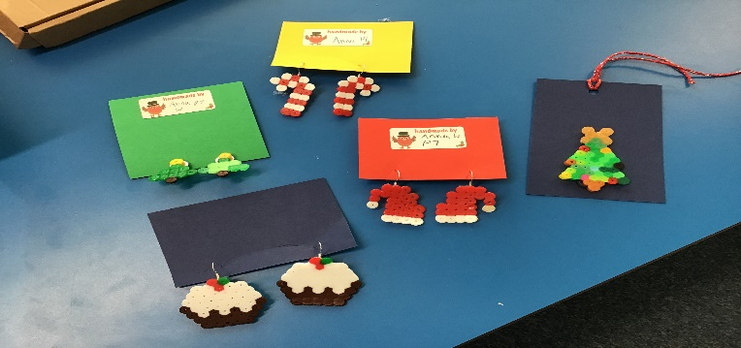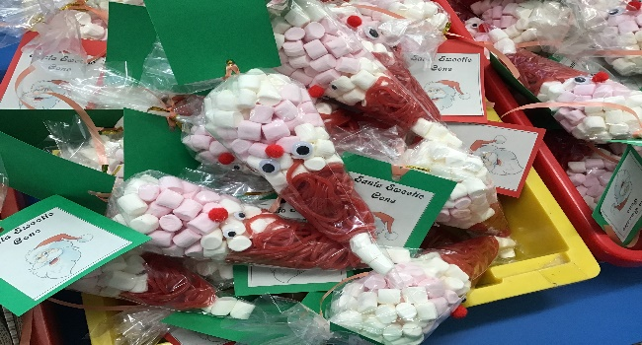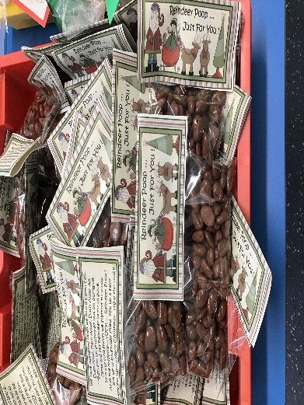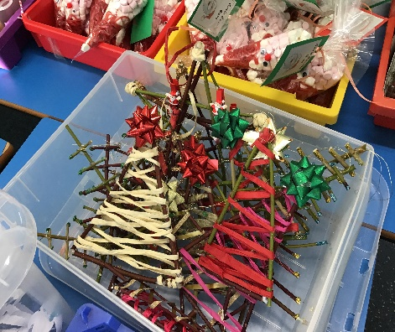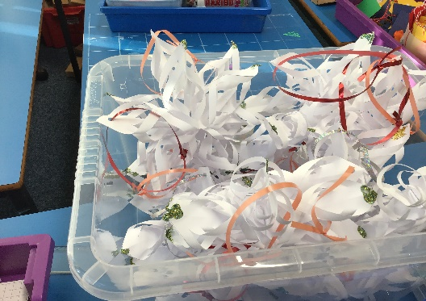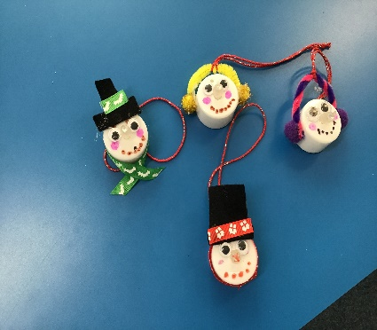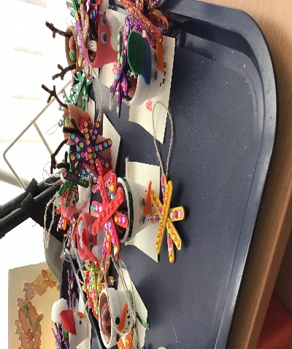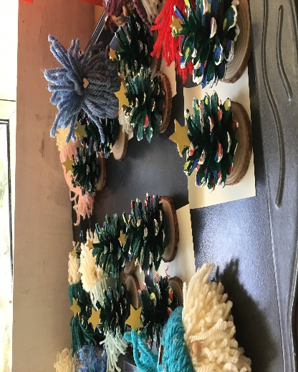
There will also be, refreshments, fresh waffles raffles, tombola, baking, bird feed, scented cones, dog biscuits, handmade keyrings, gift tags and much more. Everyone very welcome.
Children In Need
Congratulations and thank you to Mrs Davidson and our Events Team for organising a fun and successful Children In Need fundraiser for us. We raised a grand total of £230.20 which has been paid to the charity.
Strike Action
Following the communications from Aberdeenshire Council earlier this week, we can confirm that Ballater School and Nursery will be open a s usual on Thursday 8th December. We will not be impacted on by the strike action on that day.
Choir
The choir have had a very successful week with two community performances. We are now getting ready for our concert at TECA on Sunday 11th December.
A letter with full information for this event will be issued on Monday. We are very excited to taking part in this large concert.

We look forward to seeing lots of you tomorrow.

The Ballater School and Nursery Team

